

CODE NAME OF THE MODULE: PRJ60503
TYPE OF ASSESSMENT: FINAL REPORT
SEMESTER: 5
TITLE: MECHANICAL ENGINEERING GROUP PROJECT 1
MODULE COORDINATOR/SUPERVISOR: DR FAIZAL FAUZAN
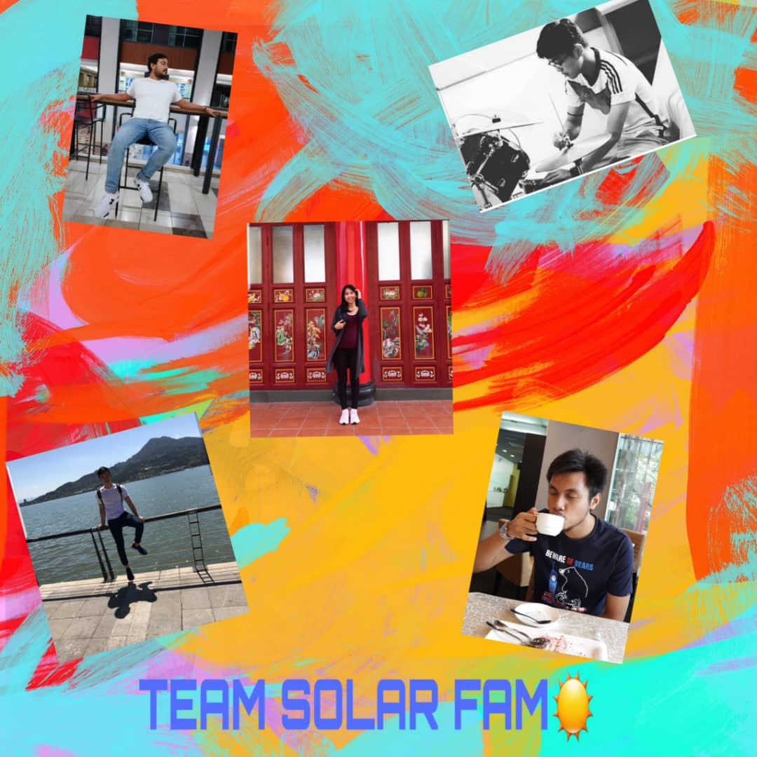
HAfis
EUGENE
ZHARIF
SAM
ARIELLE

NAME | ID | SIGNATURE
ARIELLE WONG YI-SAN | 0326426 | ARIELLE
SAMUEL TEE JIAN YANG | 0331293 | SAM
EUGENE GOW | 0326755 | EUGENE
MUHAMMAD ZHARIF NICHOL | 0331279 | ZHARIF
HAFIS MURTY | 0326357 | HM

Due Date: 7TH JULY 2019
Date of Submission: JULY 2019

CONTENT

- Introduction.................................................................................................................. 7
1.1 Background of TNB Solar Farm.................................................................... 9
1.1.1 TNB’s Future Plan..................................................................... 12
1.2 Background/Report on Fortune 11’s Solar Farm............................................ 14
1.3 Background of Karcher................................................................................... 21

- Objectives..................................................................................................................... 25

3.0 Conceive....................................................................................................................... 27
3.1 Cleaning Designs in Current Market………………………………………… 27
3.1.1 Traditional......................................................................................... 28
3.1.1.1 Ecoppia’s E4 Robot.......................................................... 28
3.1.1.2 Solarbrush UAV Robot...................................................... 29
3.1.2 Hydro................................................................................................ 29
3.1.2.1 Heliotex Water Sprinkler System....................................... 29
3.1.2.2 WashPanel.......................................................................... 30
3.1.2.3 CleanDrone......................................................................... 31
3.1.3 Ultrasonic........................................................................................... 32
3.1.3.1 Ultrasonic Bar.................................................................... 32
3.1.4 Electrostatic....................................................................................... 33
3.1.4.1 Electrostatic Film................................................................ 33
3.1.5 Coating.............................................................................................. 34
3.1.5.1 Coating Spray..................................................................... 34
3.2 Initial Decision Matrix………………………………………………………. 35
3.3 Prototype Design (Sketches) ........................................................................... 36
3.3.1 Design 1............................................................................................ 36
3.3.2 Design 2............................................................................................ 37
3.3.3 Design 3............................................................................................. 38

4.0 Design……………....................................................................................................... 39
4.1 Architecture Design...………………………………………………………... 39
4.2 Configuration Design………………………………………………………… 39
4.2.1 Design 1………………………………………………………………… 40
4.2.2 Design 2………………………………………………………………… 41
4.2.3 Design 3………………………………………………………………… 42
4.3 Integration Design……………………………………………………………. 43
4.4 Detailed Design……………………………………………………………….. 47

5.0 Analysis........................................................................................................................... 53
5.1 Cost Analysis………………………………………………………………..… 53
5.1.1 Design 1 (Dry Method) ……………………………………………... 62
5.1.2 Design 2 (Wet & Dry Method) …………………………………..…. 64
5.1.3 Design 3 (Ultrasonic Method) ……………………………………… 68
5.1.4 Conclusion from Analysis…………………………………………… 70
5.2 Business Value Analysis……………………………………………………… 71
5.2.1 Sample Calculations for Monthly/Annual Expenditures……………..72
5.2.1.1 Conventional method (manual mopping)………………… 72
5.2.1.2 Design 1 (Dry Method) ………………………………….. 73
5.2.1.3 Design 2 (Wet and Dry Method) ………………………… 73
5.2.1.4 Design 3 (Ultrasonic Method) …………………………… 74
5.2.2 Sample Calculations for Business Value Gain …………………….. 75
5.2.2.1 Design 1 ………………………………………………….. 75
5.2.2.2 Design 2…………………………………………….…….. 75
5.2.2.3 Design 3……………………………………………….…… 75
5.2.3 Sample Calculations for Annual Savings …………………….……. 76
5.2.4 Sample Calculations for Return of Investment (ROI) ……………... 76
5.2.5 Business Value Summary………………………………….………. 77
5.3 ANSYS Simulation………………………………………………………….. 78
5.3.1 Solar Panel…………………………………………………..……… 78
5.3.2 Design 1………………………………………………………….… 79
5.3.3 Design 2………………………………………………………..…… 80
5.3.4 Design 3…………………………………………………………..… 81
5.4 Solidworks Simulation ……………………………………………………… 83
5.5 3D Modelling Analysis ……………………………………………………… 84

6.0 Sustainability………………………………………………………………………... 86
6.1 Economic viability…………………………………………………………... 86
6.2 Socially acceptable/responsible……………………………………………... 86
6.3 Environmentally friendly………………………………………………..…... 87
6.4 Technologically feasible……………………………………………………... 87

7.0 Business Plan………………………………………………………………………… 88
7.1 Cost Value Analysis………………………………………………………… 88
7.2 Business Value…………………………………………………..………..… 88
7.3 6P’s……………………………………………….……………..………..… 89

8.0 Conclusion & Recommendations................................................................................ 92

LIST OF FIGURES & TABLES

Figures
- TNB’s Solar Farm located at Sepang 9
- Google’s Solar Farm in California 10
- Robotic Cleaning Method 11
- Heliotex Technology 11
- TNB Chief of Business Development and Works Minister 12
- TNB Head of Project Development and Implementation 13
- Fortune 11’s Solar Farm at Sepang, Selangor 14
- Team Picture at the Solar Farm 14
- MEMC brand Solar Panels used by Fortune 11 16
- Manual cleaning method of solar panels at the farm 17
- Team Picture with IR Mr. Rhaiz, Mr. Johari and Mr. Idham 20
- Karcher’s Solar Panel Cleaning Device, the ‘iSolar’ 23
- Ishikawa Diagram 25
- Ecoppia’s E4 Robot 28
- Schematic Drawing of Ecoppia’s E4 Robot 28
- UAV Robot 29
- Heliotex System 29
- Schematic Drawing of Heliotex System 30
- WashPanel System 30
- Schematic Drawing of WashPanel’s System 31
- CleanDrone System 31
- Schematic Drawing of CleanDrone’s System 32
- Ultrasonic Bar 32
- Ultrasonic Bar System 32
- Electrostatic Film 33
- Schematic Drawing of Electrostatic Film 33
- Coating 34
- Coating Method 34
- Sketch of Dry Method Design 36
- Sketch of Wet and Dry Design 37
- Sketch of Ultrasonic Design 38
- Solar Panel 43
- Design 1 (Dry) 44
- Design 2 (Wet and Dry) 45
- Design 3 (Ultrasonic) 46
- Engineering Drawing for Design 1 (Dry) 47
- Engineering Drawing for Design 2 (Wet & Dry) 49
- Engineering Drawing for Design 3 (Ultrasonic) 51
- Setup of the Ansys Stress test for the Solar panel frame 78
- Ansys Stress analysis of solar panel frame 78
- Setup of the Ansys Stress test for design 1 79
- Ansys Stress analysis of Design 1 frame 79
- Setup of the Ansys Stress test for design 2 80
- Ansys Stress analysis of Design 2 bars 80
- Setup of the Ansys Stress test for design 3 81
- Ansys Stress analysis of Design 3 frame 81
- Design 1 Dry Method 83
- Design 2 Wet & Dry Method 83
- Design 3 Ultrasonic Method 83
- Overview of All Assembled 3D Models 84
- 3D Model of Solar Panel 84
- 3D Models of Design 1 (Right) and Design 3 (Left) 85
- 3D Model of Design 2 85

Tables
- Estimated Cost of Using Fortune 11’s Method of Maintaining Solar Panels (Based on Time) 18
- Estimated Cost of Using Fortune 11’s Method of Maintaining Solar Panels (Based on Monetary Value) 19
- Summary of Existing Cleaning Solutions 27
- Preliminary Decision Matrix 35
- List of Materials and Resources for Design 1 40
- List of Materials and Resources for Design 2 41
- List of Materials and Resources for Design 3 42
- Bill of Material for Design 1 48
- Bill of Material for Design 2 50
- Bill of Material for Design 3 52
- Cost of Using Fortune 11’s Method of Maintaining Solar Panels (Based on Time) 54
- Cost of Using Fortune 11’s Method of Maintaining Solar Panels (Based on Monetary Value), Split into 6 Types of Costing 56
- Fortune 11’s Monthly Revenue 60
- Bill of Material to Build Design 1 62
- Bill of Material for Monthly Maintenance of Design 1 63
- Bill of Material to Build Design 2 64
- Bill of Material for Monthly Maintenance of Design 2 66
- Bill of Material to Build Design 3 68
- Bill of Material for Monthly Maintenance of Design 3 69
- Business Value for Design 1 75
- Business Value for Design 2 75
- Business Value for Design 3 75
- Comparison of all methods 77
- Ansys Stress analysis data 82
- Monthly Net Profit and Profit Margin for all cleaning methods 88
- Business value, annual savings and return of investment for all methods 88
- Final Decision Matrix 94

1.0 INTRODUCTION
With pollution on the rise during this day and age, the application and usage of renewable energy sources have been prioritized as an alternative source of power. This is due to the fact that current sources of energy used such as petroleum emit harmful gases as its by-product. This in turn damages the quality of air and the environment itself. Therefore, efforts have been made by countries all over the world to use renewable energy sources such as wind and wave energy to act as the primary source of power for everyday life.

Under the Malaysian Government’s Feed-in Tariff (FiT) system, a local electricity company, Tenaga Nasional Berhad (TNB) Energy Services has taken a step forward into the application and usage of renewable energy by outsourcing their solar farms to private companies. A good example of this would be a solar farm run by a partner company called Fortune 11 Sdn. Bhd. [3] Both parties practise a buyer-supplier relationship to provide electricity generated from the solar farm for commercial use. This project is located in Sepang, Selangor and is the first solar farm with single-axis system. More details on Fortune 11 solar farm will be discussed in Background/Report of Fortune 11 Solar Farm section. [1]

However, TNB has faced issues on the maintenance side of the solar farm. This is mainly caused by the cleaning procedure of the solar panels themselves. [1] According to IR Muhammad Rhaiz Abdul Aziz from TNB, the maintenance of the panels is not only very time consuming (manual labour) but also can be costly if automatic cleaning machines were used. This is due to the substantial amount of panels that need to be cleaned. In addition, a large amount of water is required to do the cleaning. Thus, water wastage is a possible occurrence. [1]

Nonetheless, the maintenance of these panels is essential to ensure the efficiency of solar energy that is being converted to electrical energy. [1] Based on a statement by the TNB representative, the conversion of energy drops by a rate of up to 30 % due to the panels being dirty. A study conducted by Google at their solar farm in Mountain View, California further proves and emphasizes on the cleanliness of solar panels in farms. Results obtained showed panels that were well maintained over a 15-month period were able to produce double the output of electricity that was initially expected. [2] The study also proved that using rain as a natural way of cleaning the panels was not as efficient as cleaning them professionally. Although using rain saves cost and labour, professional cleaning of the panels yielded 12 % more output as oppose to those cleaned by rain water. [2]

With maintaining the solar panels set as a top priority, TNB have looked around for alternative methods of cleaning their panels. Examples of professional methods include Heliotex technology, electrostatic cleaning and robotic cleaners. [3] All available methods will be further explored in the Literature Review section. However, these methods have one thing in common; they would cost a large amount of initial investment by TNB. For the company to turnover an acceptable profit margin, solar energy has to be widely used across the country and even so, the amount of time needed for that to happen may be long. The cost may not be be covered and instead cause a loss for the company.

Therefore, IR Muhammad Rhaiz has requested our team to come up with a locally designed and built automated robotic cleaning system that can satisfy the required needs for maintaining a large scale solar farm and also cost efficient. The project given to our team is divided into 2 parts. The first part will be focused on planning and designing the system within a time period of 14 weeks. Based on the CDIO method, this is called the Conceive (C) and Design (D) stage of the project. [6] Therefore, our team will be using the appropriate and necessary methods in this stage of CDIO to try and come up with a solution for the issue at hand. The team also has proposed a collaboration with Karcher Malaysia as they are well known for their cleaning expertise.

1.1 BACKGROUND OF TNB SOLAR FARM
In Malaysia, the local electricity company, Tenaga Nasional Berhad (TNB) Energy Services has taken a step forward into the application and usage of renewable energy by constructing a large scale solar farm. [4] This project is located in Mukim Tanjung 12, Sepang and has been in operations since 23rd November 2018. It is the largest solar farm in the country to date with an area of 98 hectares. [4] The farm uses 230000 solar panels to generate 50 MWac of electricity to the national power grid. That value has since increased to 73.2 MWac in the month of December 2018 which is in line with the Malaysian Government’s aim of promoting the use of clean and renewable energy sources. [4] The solar farm project was won by TNB’s subsidiary company, TNB Sepang Solar Sdn. Bhd., in a Government led Large Scale Solar (LSS) auction in 2017. [5] Another subsidiary of TNB, TNB Engineering Corporation Sdn. Bhd. acted as the EPC partner for the project.
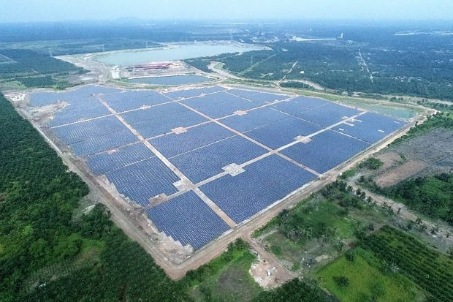
Figure 1: TNB’s Solar Farm located at Sepang

However, TNB has faced issues on the maintenance side of the solar farm. This is mainly caused by the cleaning procedure of the solar panels themselves. [6] According to IR Muhammad Rhaiz Abdul Aziz from TNB, the maintenance of the panels is not only very time consuming (manual labour) but also can be costly if automatic cleaning machines were used. This is due to the substantial amount of panels that need to be cleaned. In addition, a large amount of water is required to do the cleaning. Thus, water wastage is a possible occurrence. [6]

Nonetheless, the maintenance of these panels is essential to ensure the efficiency of solar energy that is being converted to electrical energy. [5] Based on a statement by the TNB representative, the conversion of energy drops by a rate of up to 30 % due to the panels being dirty. A study conducted by Google at their solar farm in Mountain View, California further proves and emphasizes on the cleanliness of solar panels in farms. Results obtained showed panels that were well maintained over a 15-month period were able to produce double the output of electricity that was initially expected. [2] The study also proved that using rain as a natural way of cleaning the panels was not as efficient as cleaning them professionally. Although using rain saves cost and labour, professional cleaning of the panels yielded 12 % more output as opposed to those cleaned by rainwater. [2]
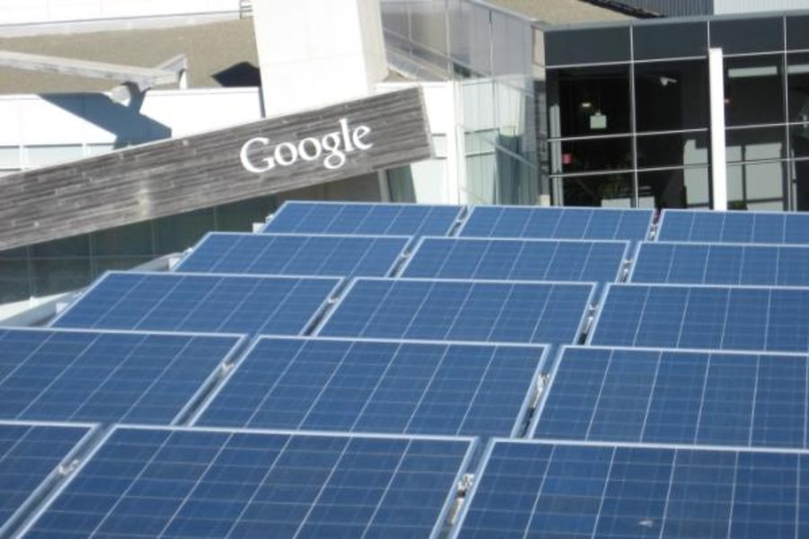
Figure 2: Google’s Solar Farm in California

With maintaining the solar panels set as a top priority, TNB has looked around for alternative methods of cleaning their panels. One example of a professional method is by using Heliotex technology. [3] This is a viable option as it not only cleans the panels professionally but also does it automatically without the need for human labour. Besides that, electrostatic cleaning is also an efficient method of cleaning the panels. Nicknamed ‘Harvesting Electricity’, this method uses electrostatic charges on transparent sheets of glass or plastic placed on top on panels to detect dust levels and activate cleaning mode when necessary. [3] Another method is by using robotic cleaning solutions. This method cleans solar panels automatically based on the specific instructions programmed into the ‘robot’ (machine). [3]

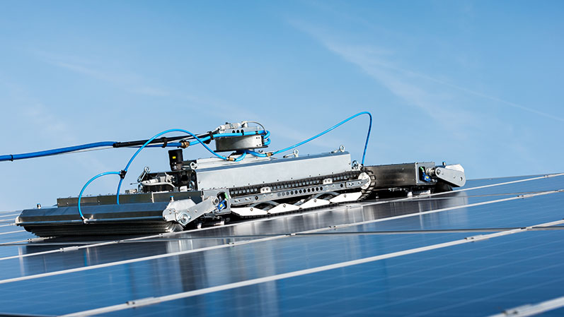
Figure 3: Robotic Cleaning Method
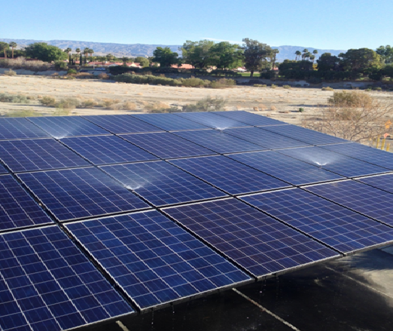
Figure 4: Heliotex Technology

However, each method mentioned had one thing in common. They all would cost a large amount of initial investment by TNB. For the company to turnover an acceptable profit margin, solar energy has to be widely used across the country and even so, the amount of time needed for that to happen may be long. The cost may not be covered and instead, cause a loss for the company. Therefore, IR Muhammad Rhaiz has requested our project team to try and come up with a locally designed and built automated robotic cleaning system that is not only able to satisfy the required needs for maintaining a large scale solar farm but also is cost-effective. The task given to the team is divided into 2 parts. The first part has a time period of 14 weeks for planning and designing the system. Based on the CDIO method, this is called the Conceive (C) and Design (D) stage of the project. [6] Therefore, our team will be using the appropriate and necessary methods in this stage of CDIO to try and come up with a solution for the issue at hand. The team has also proposed a potential collaboration with Karcher Malaysia as they are well known for their cleaning expertise. All further progress will be recorded by the team from time to time.

1.1.1 TNB’s Future Plans
As a company that acts as the main supplier of power to the entire country, TNB has taken the initiative to begin using renewable energy to generate power for the nation. Although coal and fuel are still major sources of power, TNB has plans to increase the use of renewable energy in the near future. In March 2019, TNB’s green solutions were displayed at the Asean Super Mechanical & Electrical Engineering Show at the Malaysian International Trade and Exhibition Centre (MITEC). [7] Some of its subsidiary companies were showcased there. One example was GSparx Sdn. Bhd. This company offered end-to-end solutions with zero upfront payments from its clients. Services such as consultation, monitoring and maintenance were offered without any costs involved. [7] A statement by GSparx’s head of marketing, Nor Ziha Zainol Abidin, says that the company’s current focus is on solar PV rooftops. In the future, GSparx plans to come up with battery storage solutions and many more.

A premium alternative to the PV panels provided by GSparx is actually a roof with a solar thin film built in. This product technology is provided by Tenaga Switchgear. [7] The chief of business development, Umar Ridzuan Hawari said that this alternative product has two functions. It not only generates power but also provides the usual protection against external environmental elements. He also stated that the tiles come with a home energy storage system. This system consists of a liquid-based battery system (like the voltage-regulated acid battery) which is not only safer but also does not heat up much. [7]

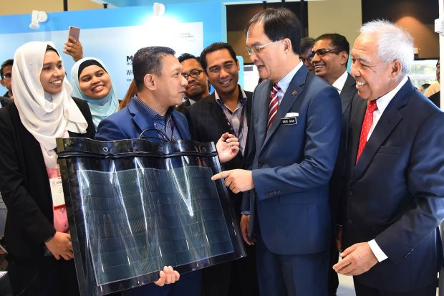
Figure 5: Umar (centre-left) explaining to Works Minister, Baru Bian (centre-right) about Solar Roof Tiles

Besides these companies, another green subsidiary, TNB Engineering Corporation Sdn Bhd (TNEC) focuses on large scale solar farm setups in addition to district cooling systems (DCS). [7] Head of Project Development and Implementation, Rizuan Eusoff said in a statement,
“Basically our major businesses are district cooling systems plants and large-scale solar installation.” “District cooling plants, like the one at KLIA2, is a centralised air conditioning plant that supplies chilled water to the whole KLIA2 airport development. A district cooling plant with thermal energy storages is able to reduce the electricity cost compared to conventional plant.” [7]
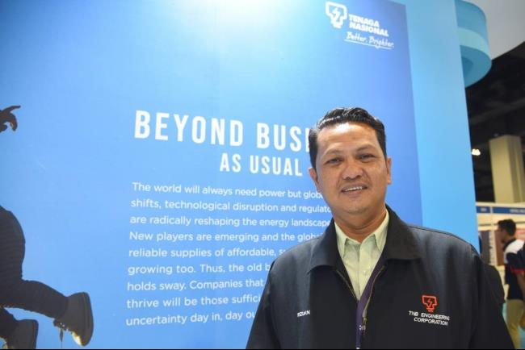
Figure 6: Rizuan Eusoff at MITEC

TNEC provides the full range of services related to DCS. He also added that TNEC spearheaded the construction of 2 large scale solar farms in 2018 which are, the well-known 50 MWac capacity farm, TNB Sepang Solar in Selangor and the 29 MWac capacity farm, Leader Solar Energy in Sungai Petani, Kedah. A brand new 30 MWac solar farm located in Bukit Selambau, Kedah is under construction and shall be completed by 2020. [7]
In fact, the solar farm project in Bukit Selambau only got approved recently. The project got the ‘Green Light’ after TNB’s unit, TNB Bukit Selambau Solar Sdn. Bhd. (TBSS) secured a financial close for the project worth RM 144 million with MUFG Bank (M) Bhd. [8] The bank has agreed to provide all the funding and capital required by the project. TBSS was awarded the project by TNB’s Energy Commission through a competitive bidding system. A statement by TNB noted that the solar farm would have a generation capacity of 30 MW with a direct current installed capacity of 45 MWp. [8] TNB further stated that all of its solar farms further reinforces their commitment and aspiration towards the application and expansion of the use of renewable energy in Malaysia. 20 % of the country’s electricity is targeted to be produced by renewable energy sources by 2030. This is a major increment from the current value of 2 % according to The Energy, Science, Technology, Environment and Climate Change Ministry. [8]
1.2 BACKGROUND/REPORT ON FORTUNE 11’S SOLAR FARM
Since TNB’s Solar Farm is unavailable for public access due to an unfinished entrance road, TNB’s IR, Mr. Rhaiz and our module coordinator/ lecturer, Dr. Faizal have requested for us, Team Solar Fam to focus our project on TNB’s partner’s solar farm run by a local company known as Fortune 11. [9] Hence, on the 29th of April 2019, we made a site visit to their solar farm located in Sepang, Selangor to gather more insight on the current state of the farm and the issues that they face with cleaning the solar panels available there.

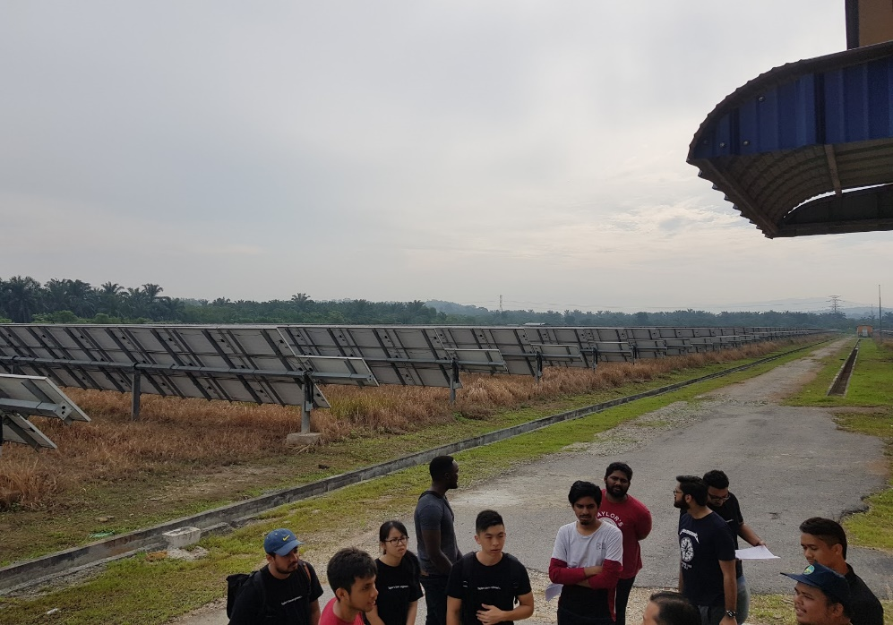
Figure 7: Fortune 11’s Solar Farm at Sepang, Selangor
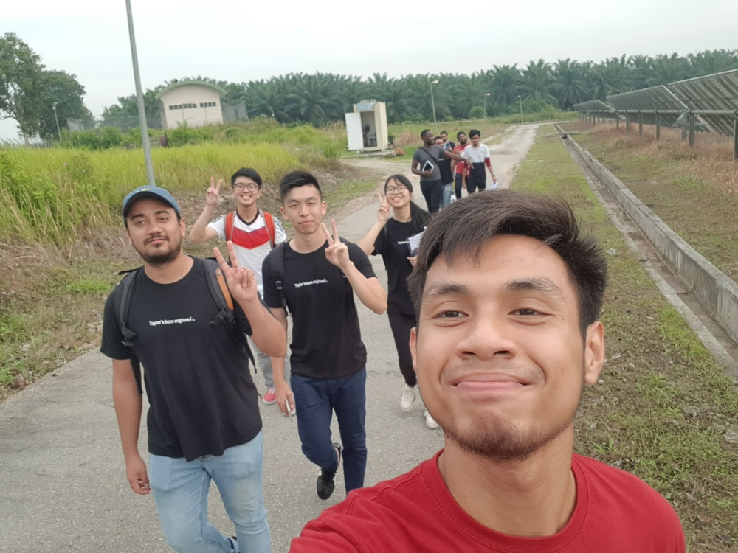
Figure 8: Team Picture at the Solar Farm

Our lecturer, Dr. Faizal also took the time off to tag along with the team for the site visit. At the farm, we managed to meet up with Fortune 11’s Head of Operations & Maintenance, En. Idham along with the farm’s caretaker, En. Johari. [9] Since they both have a first-hand experience of maintaining the solar panels on the farm, our team prepared a questionnaire prior to our visit for them to answer. This was to allow the team to gain more information on the farm and the cleaning methods currently used on the solar panels.

LIST OF QUESTIONS FOR TNB
- Type of solar panel TNB used (lifetime)
- Size of panel (Dimensions/Weight)
- Specification of solar panels (electricity generated)
- How they clean it /problems faced cleaning
- How often?
- How they detect and know when to clean the solar panel
- Cost of cleaning & labour / no. of workforce required
- Types of dirt (bird shit or dust, leaves)
- Pics & vids of worker cleaning the panels
- How they know if it's clean enough (if got graph, numbers/ figures as proof)
- Confirm number of panels
- Expectation from TNB/ budget given for Team solar fam
- Max weight / force applied can be on top of panel

From our meeting and interview with Mr. Idham and Mr. Johari, we managed to gain a lot of information about the solar farm. Firstly, the solar farm is 20 acres in size and contains 17120 solar panels. [9] The solar farm has a plant capacity of 5 MWh and it is able to generate up to 20 MWh of electricity per day. The electricity generated is then converted to have an AC output for distribution to TNB and other customers that they have. [9] The solar panels used by Fortune 11 are from a local manufacturer known as MEMC Electronic Sdn. Bhd. (formerly known as SunEdison Sdn. Bhd.) [9]

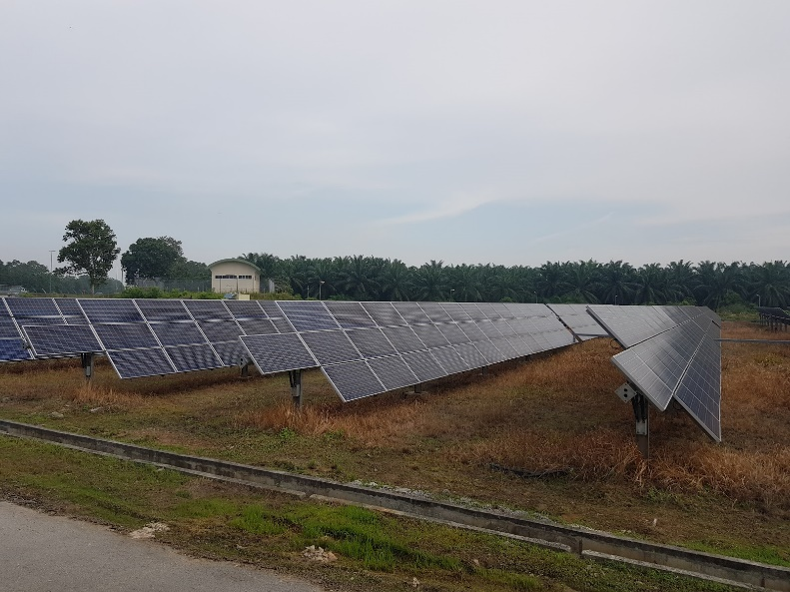
Figure 9: MEMC brand Solar Panels used by Fortune 11

In addition to these, 3 types of solar panels are used on the farm. [9] They vary in terms of power output by each panel. The difference in power is as shown below:
- 290 W
- 295 W (Average power output of each panel)
- 300 W

The panels are also arranged in a way whereby there are 40 panels in a set and there are 4 sets in a row. [9] The sets of panels have an estimated gap of 1.12 m in between them. This, according to Mr. Idham, is to allow for the circulation of air to occur. This is especially crucial during windy periods and heavy downpour as the panels are prevented from falling over and being blown away with the help of the air gaps. [9] Furthermore, the solar panels have an automated moving feature (single-axis system) that allows the panels to move in the direction of the sun. This is possible due to the panel’s movement path being pre-programmed using a programmable logic controller (PLC) system.

The location of this solar farm is isolated and the solar panels are fixed higher from the ground. Hence, it suffers from fewer types of contaminants (mainly dust, mud and bird droppings) as compared to other solar farms that are close to areas prone to contaminants such as rubbish dump sites.

Regarding the cleaning methods used for the solar panels, our questions were answered by Mr. Johari, who is the lead caretaker of the farm. We found out that the most common method of maintaining the panels is by using natural rain water. [10] According to Mr. Johari, this technique is used because there are no extra cost and labour involved. If the panels were not able to be cleaned by rain, then a couple of workers needed to use a mop and water to further clean the panels (manual method). No nylon material and soap or chemical cleaning solution is used due to concerns of potential damage to the solar panels. Although these are not the best maintenance methods for solar panel efficiency, they are used regardless due to the fact that advanced solar panel cleaning methods are very expensive. [10]

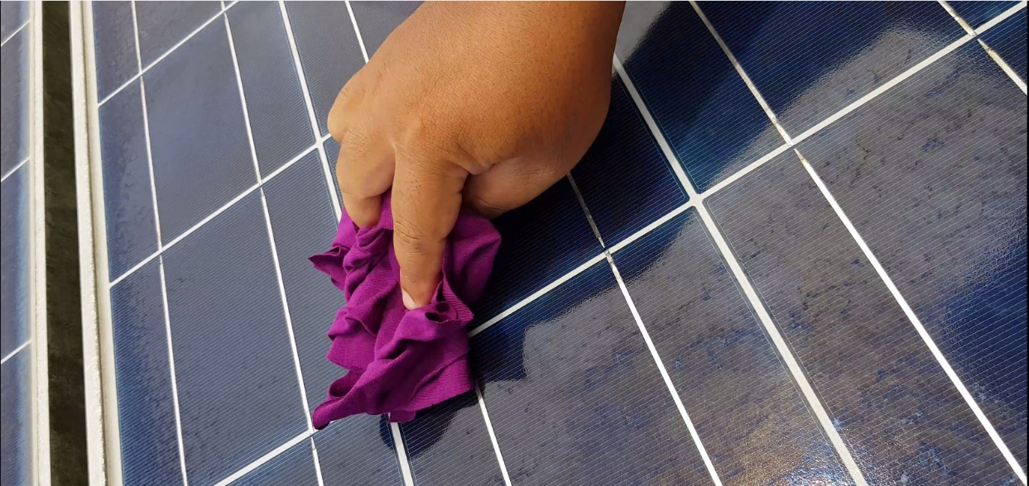
Figure 10: Manual Cleaning Method of Solar Panels at the Farm

If there are insufficient rainy periods, then the manual method is used to clean the panels once a month. [10] Mr. Johari also stated that the cleanliness and condition of the solar panels are visually monitored. This is due to the absence of an automated tracking and inspection system. The cost, based on monetary value and time, of having daily inspection and cleaning of panels is as shown in the table below. [10]

Table 1: Estimated Cost of Using Fortune 11’s Method of Maintaining Solar Panels (Based on Time)
Number of Workers | 10
Total Number of Solar Panels | 17120
Number of Available Working Days per Week | 5 days
Standard Working Hours per Day | 9 hours
Total Working Hours per Week | 45 hours per week
Cleaning Method Used | Manual (Water, soap, brush/ mop)
Time to Clean & Inspect 1 Panel | 1 minute 15 s
Number of Solar Panels in a Set (Row) | 40
Amount of Panels Cleaned & Inspected by 10 Workers in 5 minutes | 40 (4 panels per worker)
Number of Panels Cleaned & Inspected per Hour | 480 Panels per Hour
Number of Panels Cleaned and Inspected per Working Day | 4320 Panels per Day
Total Time Required to Clean & Inspect All Panels (1 cycle) | 4 days
Number of Cleaning Cycles in a Month | 5 cycles

Table 2: Estimated Cost of Using Fortune 11’s Method of Maintaining Solar Panels (Based on Monetary Value)
Total Cost of 10 Worker’s Salary per Month  (5 working days, 4 weeks per month) | RM 12000 per Month
Total Cost of Soap per Month | RM 4708
Total Cost of Water per Month | RM 19509.45
Total Cost of Brushes per Month | RM 1712
Total Cost of Mops per Month | RM 170
Total Monthly Cost (Expenditure) | RM 38059.45

Based on the table, it can be seen that the cost is extremely high for daily cleaning and inspection of solar panels. To avoid losses, Fortune 11 prefers the current method of solar panel maintenance being used. [10] However, the current method decreases solar panel efficiency in the long run.

Therefore, TNB’s IR, Mr. Rhaiz has requested for us to focus our project on solving this issue. The expectation is for us to build an autonomous solar panel cleaning robot that is:
- Effective and efficient
- Lightweight and easy-to-use
- Low cost and maintenance
- Adaptable to shifting arrangements of solar panels
- Flexibility in cleaning various types of contaminants
- Has its own dirt tracking system [11]

The product of our project will be tested out on Fortune 11’s farm first before getting approval from TNB themselves.
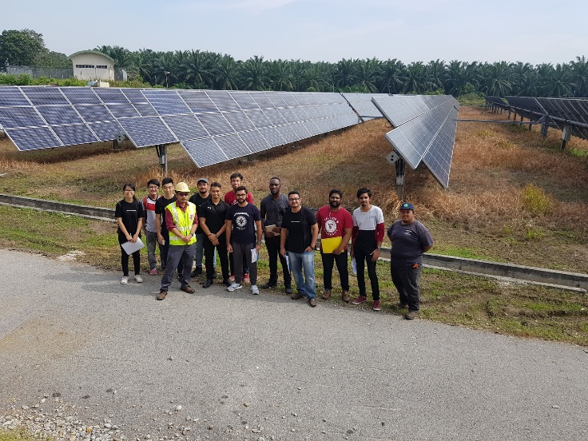
Figure 11: Team Picture with IR Mr. Rhaiz, Mr. Johari and Mr. Idham

Lastly, Team Solar Fam had decided to collaborate with a top industrial company Karcher Malaysia who is also an expert in cleaning and maintenance technology. Therefore, a research on the background of Karcher Malaysia was conducted to gather more intel the product they have and use.
1.3 BACKGROUND OF KARCHER
Alfred Kärcher GmbH & Co. KG also known as Karcher, is a leading worldwide supplier of cleaning systems and technology. [12] It was started by the owner and inventor himself, Alfred Kärcher back in 1935. Karcher has always been renowned by its innovative thinking and ingenuity since its very start. [12] Alfred Karcher began producing and marketing his revolutionary product ideas in the field of heating technology. In 1950, he managed to invent Europe’s first hot water high-pressure cleaner which acted as the foundation for the company to grow into the world’s leading cleaning specialist. [12] Karcher is still a family-owned company till this day with its headquarters located in Winnenden, Stuttgart.

The company’s mission statement contains 12 criterias which are as listed below: [13]
- Innovation
- Customer focus
- Employees
- Product and service range
- Cooperation
- Market position
- Social responsibility
- Resource handling
- Marketing
- Growth, finance & earnings
- Production and purchasing
- Family-owned company

Karcher products have always been the preferred choice of people from around the world due to their reliability, competency and innovation. [12] The products are split into two categories which are, Home & Garden and Professional. Under the Home & Garden category, the products available are mainly for light everyday usage such as for household cleaning and car washing companies. Vacuum cleaners, floor cleaners, water jets and steam cleaners are examples of machines that are produced by Karcher under this category. [12] As for the Professional division, the products here are for heavy everyday usage such as for construction sites and factories. Examples of products available in this category are industrial vacuums, sweepers, high pressure hot water cleaners and floor scrubbers. [12]

The year 2017 witnessed Karcher’s highest turnover in its history with a value of 2.5 billion Euros. [12] This is due to the contribution of its employees, after sales services and products sold. The company has more than 12300 employees in 67 countries and owns over 110 subsidiary companies worldwide. [12] A consistent level of support and after sales service is provided worldwide with over 50000 service offices available. As innovation is the main catalyst for the company’s growth, 90 % of all Karcher products are updated within the span of 5 years or less. This is possible due to the company’s research and development (R&D) team having over 1000 employees. [12]

Karcher defines business success the same way till this day as: [12]
- Above average investment in R&D
- Latest production methods
- High quality and advanced training for its employees
In addition to this, the company also supports social facilities and cultural events. For example, Karcher, along with the Global Nature Fund in emerging and developing nations, have been providing cleaning equipment and building green filter plants in SOS’s children’s village for over 80 years. [12]

As for its cultural sponsorship programme, more than 140 monuments worldwide have been cleaned with the help of Karcher since 1980. [12] Among the monuments involved in this initiative are:
- Brandenburg Gate, Berlin
- Statue of Christ, Rio De Janeiro
- Colonnades in St. Peter’s Square, Rome

The cleaning of these monuments is always in partnership with art historians and monument protection official restores. [12] In addition to these, Karcher also has its own solar panel cleaning system, nicknamed the ‘iSolar’. [14] This system consists of several products that when used together, can thoroughly clean solar panels. The iSolar has an edge over other solar panel cleaning methods due to it having unlimited methods of usage. [14] The iSolar is able to provide superior cleaning of solar panels because it has specialized rotating brushes which are powered by water jets from a pressure washer. The specialized brushes are made of nylon which prevents scratches on the surface of solar panels. [14] The system also operates at a low pressure to avoid the possibility of damaging the solar panels. The iSolar is split into 2 main models, namely the iSolar 400 and iSolar 800. The difference in the models is because of the amount of brushes being used. The iSolar 400 only uses one-disc brush while the iSolar 800 contains a dual counter-rotating disc brush. [14] The iSolar 400 is suitable for small to medium sized solar panels while the iSolar 800 is able to clean large solar panels.
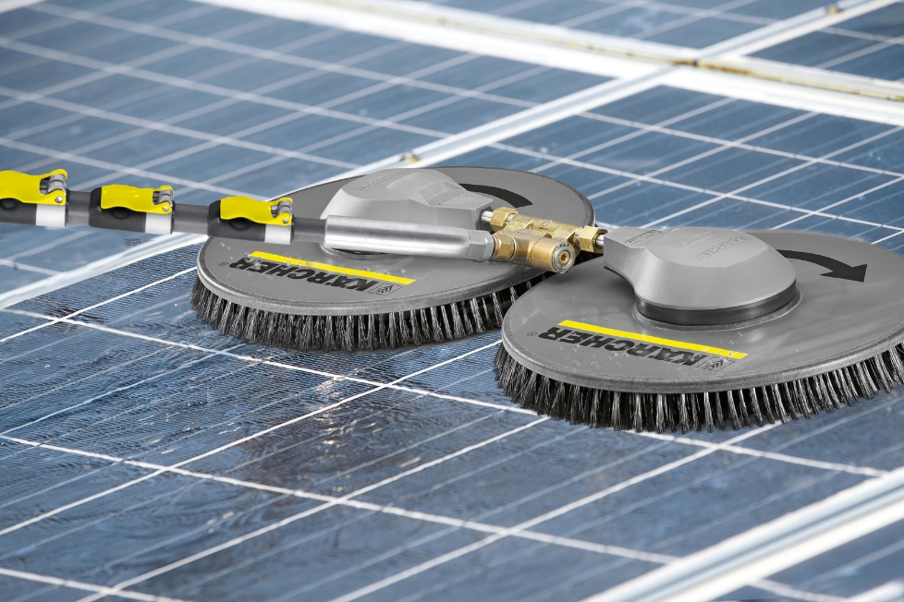
Figure 12: Karcher’s Solar Panel Cleaning Device, the ‘iSolar’

Besides that, the system also has telescopic lances which extends the cleaning range of solar panels to an area of 45 feet. The lances are easy to use and feature a ‘plug-and-play’ concept. [14] Furthermore, the iSolar also comes with its own safety system for solar panels which are located in high-to-reach areas. The RM 99 Solar Cleaner detergent is also provided and further enhances the cleaning process with its effective and gentle cleaning nature suitable for solar panels. [14]

Lastly, the iSolar system is able to be paired with all of Karcher’s water jet machines that will act as the ‘engine’ which drives the system. However, the system is costly and requires manual labour to operate it. Our industrial partner, TNB may not be able to afford the system or gain substantial profit from using it. Therefore, due to Karcher’s vast experience and long history in cleaning machines and systems, our project team, Team Solar Fam, intend to work together with the company to come up with a solution and build an autonomous cleaning robot for cleaning the solar panels in TNB’s solar farm.

2.0 OBJECTIVES
To find the root causes of our challenge, we gathered information and asked all possible questions regarding the challenge. This aids in designing a solution that addresses all the root causes the first time around or with as little changes needed.

The Ishikawa Diagram technique involves classifying the potential causes of an issue in order to pinpoint its root cause. This diagram also helps us to organize the causes systematically and act as a guide for us to create solutions.

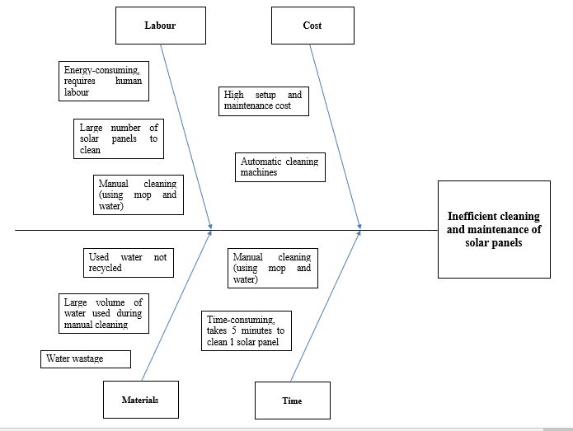
Figure 13: Ishikawa Diagram

Based on Figure 13 and also referring to the section Background/ Report on Fortune 11 Solar Farm, the objectives are:

1. To complete extensive research, planning and design in the form of Interim Report and Final Report by Week 14 of Semester 5.

2. To create an autonomous solar panel cleaning robot which is:
- Effective and efficient
- Lightweight and easy-to-use
- Low cost and maintenance
- Adaptable to shifting arrangements of solar panels
- Flexibility in cleaning various types of contaminants
- Has its own dirt tracking system

3. To complete the construction of the final working product by Week 14 of Semester 6.

3.0 CONCEIVE
Before starting to generate ideas for designs (conceive), the team first did research on the current cleaning methods and procedures used by identical solar farms and companies in the market. This was to help the team narrow down the methods used into smaller categories. By carrying out this research, the team also gained more knowledge on the types of technology currently available and being used in the market. This in turn helped the team in the design process.
3.1 CLEANING DESIGNS IN CURRENT MARKET
Below is an overview of the various cleaning methods and their respective commercial cleaning solutions. The focus is primarily on fully autonomous commercial cleaning solutions capable of cleaning solar panels in a slanted position:

Table 3: Summary of Existing Cleaning Solutions
Cleaning Method |  | Existing Solution
 |  | Commercial Solution | Solution Type
Traditional | Dry | Ecoppia’s E4 | Fixed
 |  | Solarbrush UAV Robot | Unmanned aerial vehicle (UAV)
Hydro | Wet | Heliotex | Fixed
 |  | Washpanel | Fixed
 |  | CleanDrone | Unmanned aerial vehicle (UAV)
Ultrasonic | Dry | N/A* | Fixed
Electrostatic | Dry | N/A* | Fixed
Coating | Dry | Solar Sharc | Spray-on
*No commercial solution available currently but technology exists

3.1.1 TRADITIONAL
3.1.1.1 Ecoppia’s E4 Robot
E4 is a fully autonomous and water-free robotic cleaning system. [15] Referring to Figure 1, E4 consists of 2 main bodies; the robot and the guide rail. From Figure 2, the robot comprises 2 rows of rotating shafts with microfiber brushes that sweep of dust from solar panels. A pulley concept is utilised to achieve this rotation. With the help of small wheels, robot also moves up and down the guide rail. Similarly, the guide rail, which is fixed to the edge of a single solar row, moves laterally along the panels with the aid of wheels driven by a motor. These wheels support the guide rail in both perpendicular and parallel directions relative to the surface of the solar panel. [16]

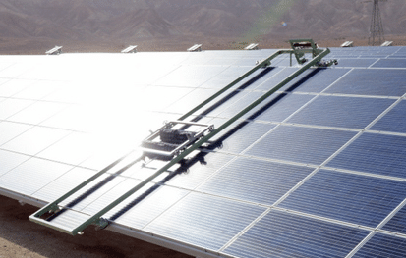
Figure 14: Ecoppia’s E4 Robot

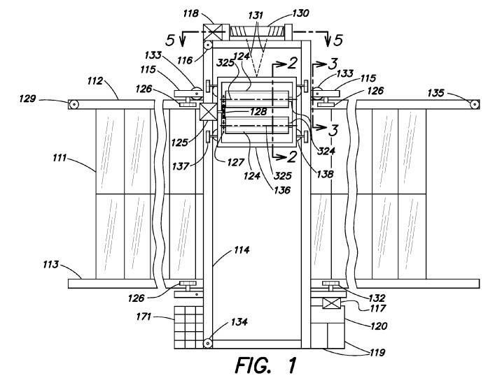
Figure 15: Schematic Drawing of Ecoppia’s E4 Robot Concept

3.1.1.2 Solarbrush UAV Robot
This UAV robot, or commonly known as a drone, cleans solar panels in the air using pre-programmed flight paths. It is composed of 4 sets of propellers and an rear attachment or ‘tail’ which is a essentially a brush. The tail, being the only component that makes contact with the solar panel, sweeps across the panel surface to brush off dirt and/or dust to the ground. [17]
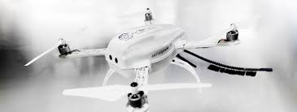
Figure 16: UAV Robot

3.1.2 HYDRO
3.1.2.1 Heliotex water sprinkler system
Akin to a sprinkler system, Heliotex affixes nozzles directly to the frame of solar panels using double faced adhesive shafts. From Figures 4 and 5, the tubes channel water coming from the main system into the nozzles to be dispensed onto the panels. [18] The central unit of the system is installed on the ground and includes a soap reservoir, pump, water filter and valves. One of the valves is used to connect the soap storage compartment to the water supply line. When the valve is open, soap flows into the water supply line and mixes with water to produce the cleaning fluid. A programmable controller positions the valve to be either opened or closed. Also, a control panel is provided from which 2 functions can be programmed; washing of solar panels using biodegradable detergent or rinsing of solar panels with plain purified water. [19]
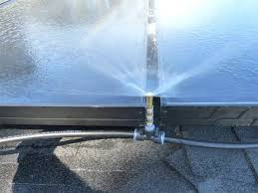
Figure 17: Heliotex System

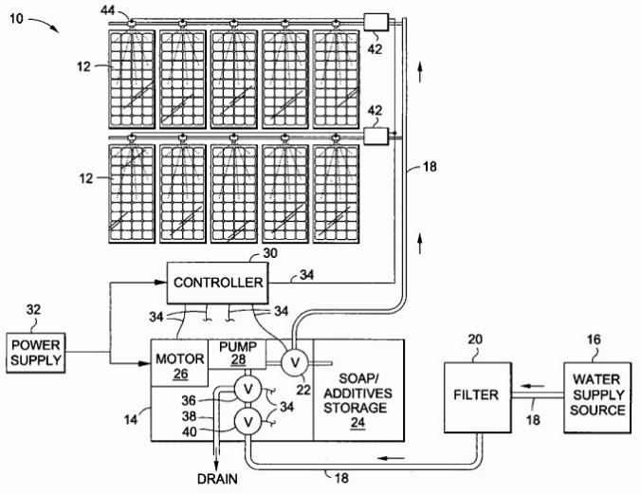
Figure 18: Schematic diagram for Heliotex System

3.1.2.2 WashPanel
Generally, WashPanel works similarly to Ecoppia’s E4 with a few exceptions such as that it uses the wet method. WashPanel is able to continuously move through gaps and treat different solar rows as well. It is fixed to the edge of a single solar row and moves horizontally over the array of panels. To carry out this motion, a long shaft (labelled 8) connecting the bottom set to the top set of wheels is driven by a motor (labelled 6). [20] The cleaning system combines a long rotating vertical brush and a water hose to wet the panels. WashPanel has sensors and an interface to program the washing system. [21]
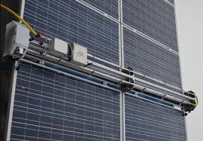
Figure 19: WashPanel System

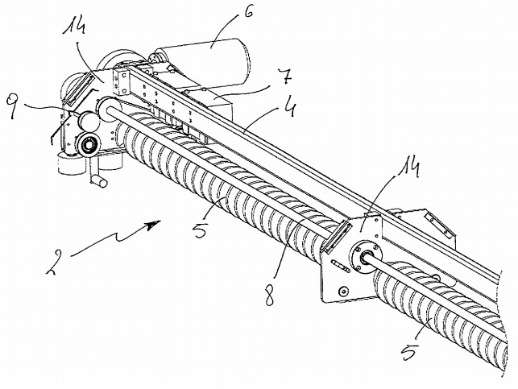
Figure 20: Schematic Drawing of WashPanel System

3.1.2.3 CleanDrone
This UAV robot is a multicopter that also uses the wet method to clean solar panels. It is equipped with pusher propellers and utilises computer vision, sensors and artificial intelligence algorithms to detect and clean surfaces. [22] A cleaning device with a detachable cleaning fluid container protrudes from the front of the robot. The device comprises two straight flexible squeegee blades, water suction system and many other components all connected in a complex manner. To ensure low water usage, the system dispenses, recovers and reuses cleaning fluid during the cleaning process. [23] On a side note, a team of CleanDrones can work autonomously under the coordination of a Ground Control System (GCS) and with automated docking stations that recharge batteries and change cleaning fluid. [22]
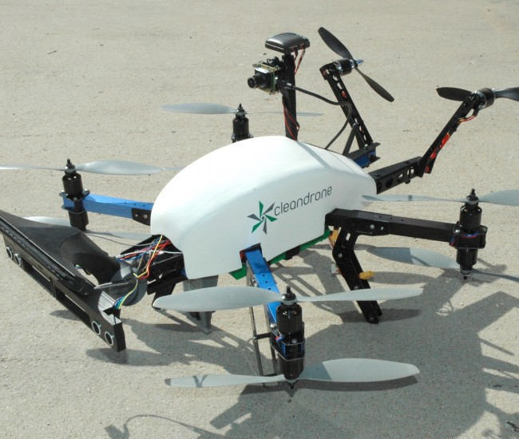
Figure 21: CleanDrone System

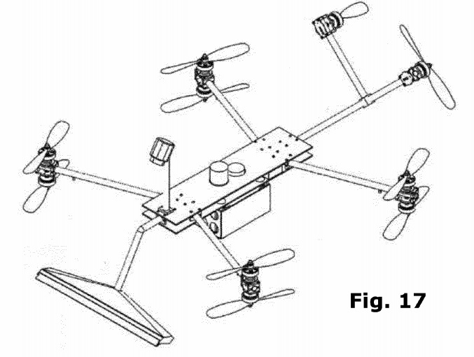
Figure 22: Schematic Drawing of CleanDrone System

3.1.3 ULTRASONIC
3.1.3.1 Ultrasonic Bar
Although this cleaning method has not hit the commercial market yet, an apparatus has been made and is still undergoing further development. Referring to Figure 10, the apparatus consists of a bidirectional ultrasonic piezoelectric vibrator (labelled 1) and 2 long plates (labelled 2) joined to each side of the vibrator. Electrodes are placed on both sides of piezoceramics. Piezoelectric rings and the vibrator’s parts are joined together using structural steel piston. All components are adhered together. Figure 11 shows 1 set of the apparatus (indicated by the red box) mounted on the solar panel. More copies of this apparatus are repeatedly mounted on the whole panel with a consistent distance between them. [24]
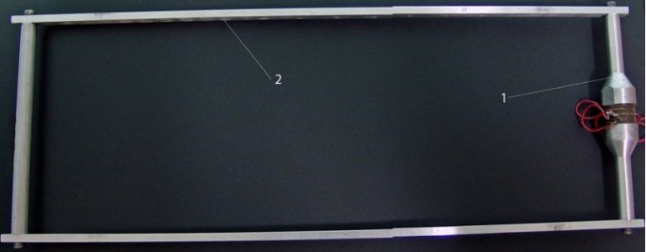
Figure 23: Ultrasonic Bar

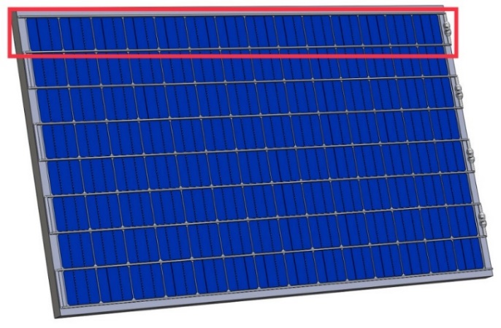
Figure 24: Ultrasonic Bar System

3.1.4 ELECTROSTATIC
3.1.4.1 Electrostatic Film
This is another cleaning method that exists but has not been developed into a commercial product yet. From Figure 12, the device is made up of parallel screen electrodes that are attached in plastic frames in lattice geometry. The electrodes are composed of copper wire and coated with a polyester film. The electrical component comprises a set of small positive and negative on-board type amplifiers, photoMOS relays and controlled by a microprocessor. This device is meant to be mounted on the solar panel. [25]

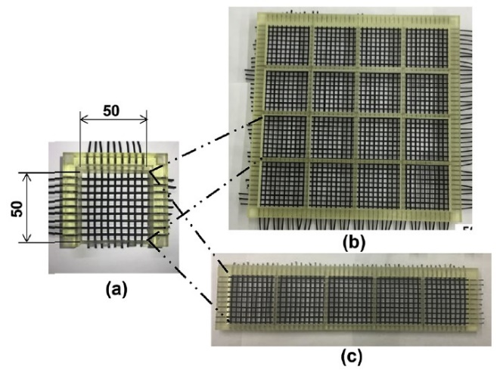
Figure 25: Electrostatic Film

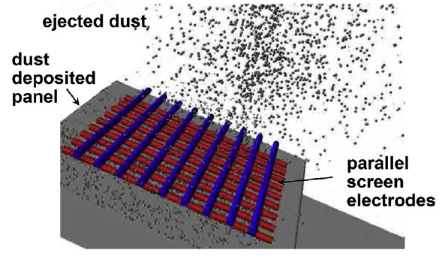
Figure 26: Schematic Drawing od Electrostatic Film

3.1.5 COATING
3.1.5.1 Coating Spray
Solar Sharc is a spray-on hydrophobic coating that is self-cleaning, meaning surface contamination (dirt, dust, etc.) will not stick or accumulate on the film. Since it is hydrophobic, water droplets will form beads on the coating and roll off instead of wetting the surface. This mimics the nature of a lotus leaf. The coating also contains anti-reflective properties, allowing over 93% of all available light to reach the solar panel. [26] One thing to note is that the coating method does not have high durability and requires coating reapplication. [27]

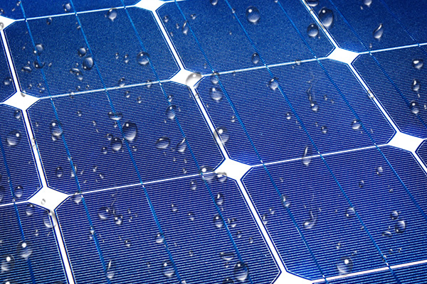
Figure 27: Coating

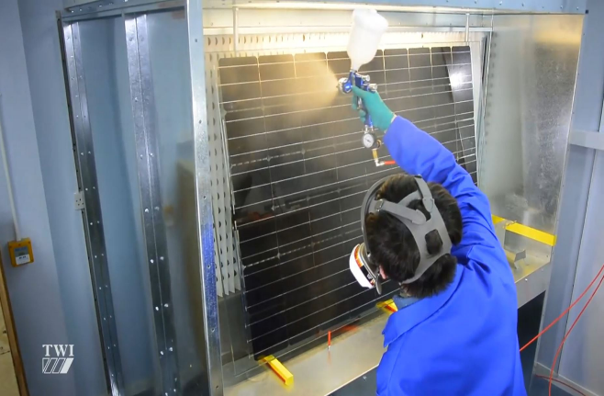
Figure 28: Coating Method

3.2 INITIAL DECISION MATRIX
To narrow down the 5 available cleaning methods, a decision matrix was utilised as shown in the table below. The methods were judged based on certain criterion such as cost, reliability & performance, feasibility, ease of use & safety and aesthetic appeal. The methods were given appropriate ratings based on the relevant criteria and their respective weightages were predetermined by the team. As a result, the top 3 methods chosen were traditional (dry), hydro and ultrasonic.
Table 4: Preliminary Decision Matrix System
Criterion | Weightage | Traditional  (Brush, compressed air) | Hydro  (Heliotex, Water Jet, Steam) | Ultrasonic | Electrostatic | Coating
Cost | 5 | 5 | 4 | 2 | 1 | 3
Reliability and Performance | 4 | 4 | 5 | 3 | 2 | 1
Feasibility | 3 | 5 | 4 | 2 | 1 | 3
Ease of Use / Safety | 2 | 5 | 4 | 3 | 2 | 1
Appeal | 1 | 1 | 5 | 4 | 3 | 2
Total: |  | *67 | *65 | *38 | 23 | 32
*Top 3 cleaning methods chosen based on the Decision matrix system (Traditional, Hydro, Ultrasonic)

3.3 PROTOTYPE DESIGN (SKETCHES)
Based on the results of the initial decision matrix, the team then proceeded to sketch designs for each of the cleaning methods chosen. Taking inspiration from existing designs, the team came up with 3 designs of the autonomous solar panel cleaning robot. Design 1 incorporated the traditional (dry) cleaning method while Design 2 fused both dry and wet cleaning methods. Design 3 used the lesser-known ultrasonic cleaning method which requires a slight amount of water to create acoustic pressure.

3.3.1 Design 1
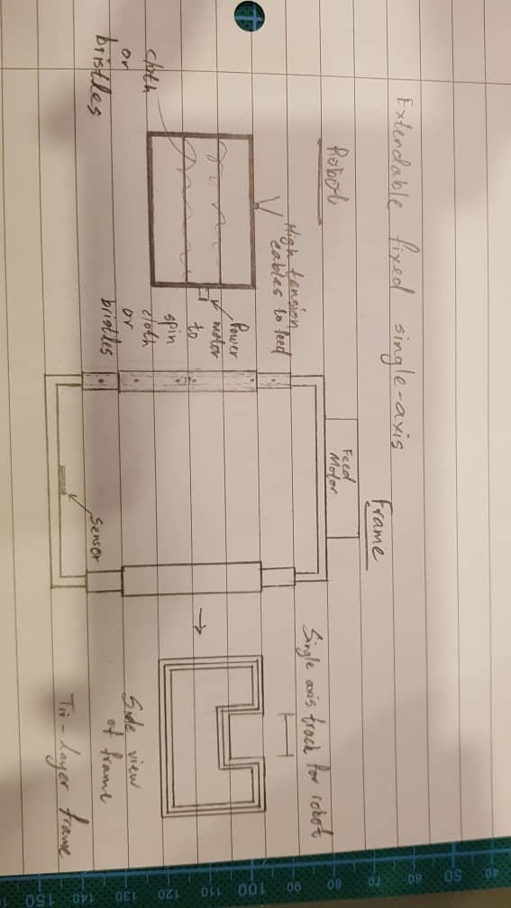
Figure 29: Sketch of Dry Method Design

This design consisted of both the robot made out of a stainless steel frame and an extendable frame made out of aluminium where the robot sits on the frame and moves in the single axis track downwards from top to bottom (y-axis). Inside the robot, microfiber cloth or a high tensile brush is installed which is connected to a motor that will rotate the cloth or brush which creates a rotary force that can clean dust and debris on the solar panel without causing any abrasions on to the solar panel. The robot moves from the top to bottom and returns to the top when it hits the sensor located at the bottom of the frame. The motor that rotates the brush and cloth is powered by a small solar panel or it can be powered by a rechargeable battery. The frame is moveable with wheels attached and placed at each corner of the aluminium frame enabling it to move sideways whilst latching on to the panel (x-axis).

3.3.2 Design 2
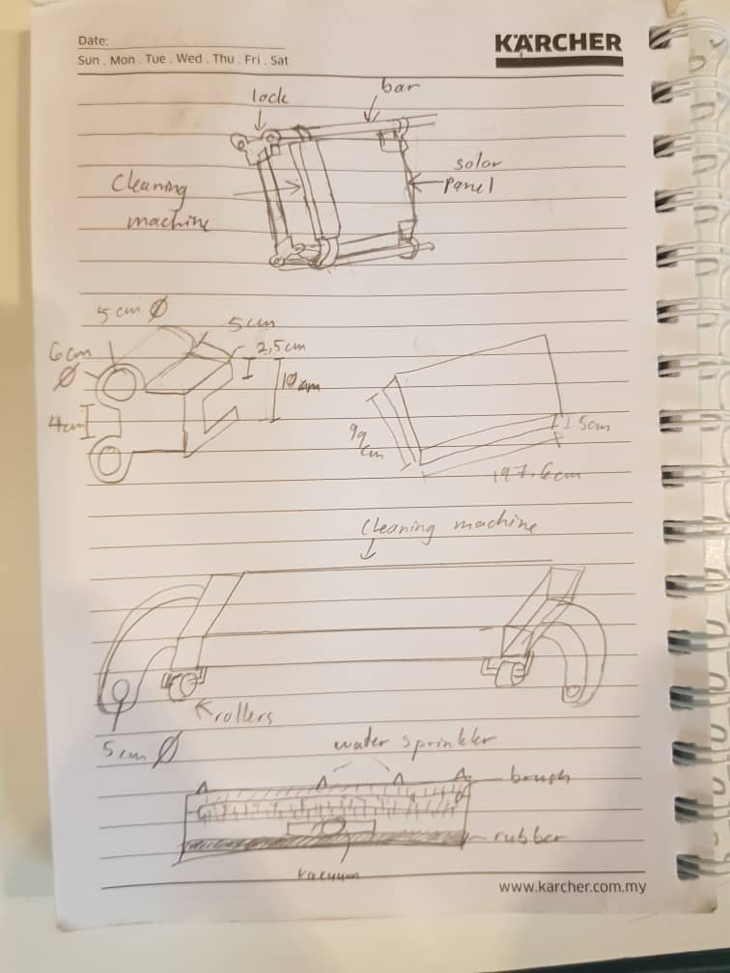
Figure 30: Sketch of wet and dry design

This design consisted of a frame and a machine. The cleaning machine has a water sprinkler at the front to eject small dosages of water and the brush with the lateral movement will scrub the dirt and dust off the panel surface. A rubber lip is attached at the rear end to prevent dirt, dust and water from spilling out at the sides and direct it to the vacuum hole. The frame consists of the bar and lock where the lock is locked on the edge of the solar panel and holds the bar in place. The machine has rollers placed underneath to help facilitate the movement of the machine as it moves across the surface of the panel. The arms at the side are clamped onto the bar so that it moves in the lateral direction and to let the machine stay on its path.

3.3.3 Design 3

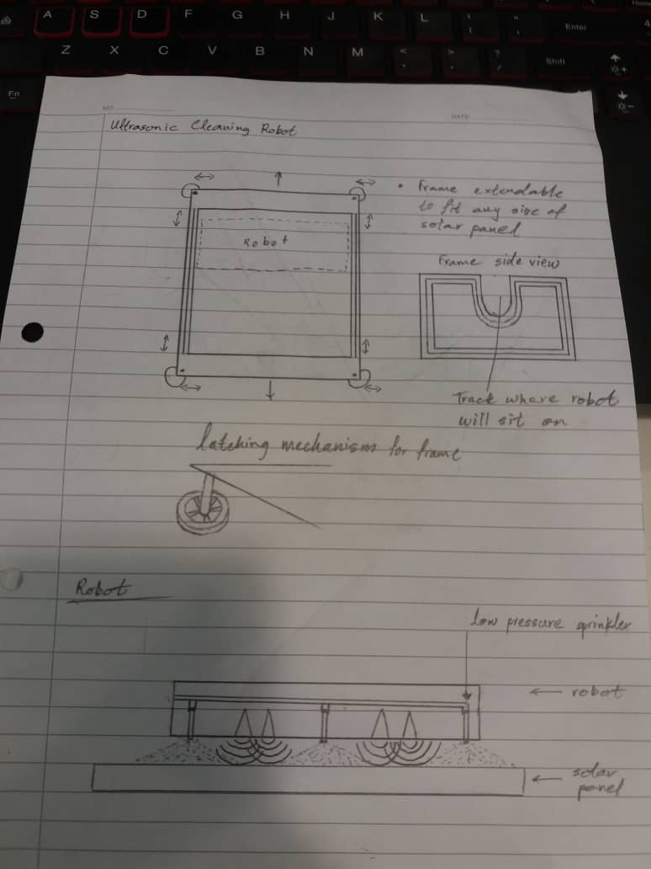
Figure 31: Sketch for the ultrasonic design

This design also consisted of an aluminium body and a stainless steel frame. The frame also has a track where the wheels of the robot will move in one axis (y-axis). The wheels on the frame move along the side of the panel (x-axis). The robot itself rests on the tracks of the frame and consist of a low-pressure sprinkler system and piezo ceramic actuators that emit ultrasonic waves to create acoustic pressure on the water sprinkled onto the solar panel. The agitation of the water scrubs the dirt and dust away from the panel surface. A motor moves the robot back to the top of the frame and powers the piezo ceramic actuators.

4.0 DESIGN
4.1 Architecture Design
First, from the knowledge and information gained from interviewing the workers at Fortune 11’s solar farm and from the initial decision matrix, we managed to figure out a way to help fix and ease the work flow of the workers. We initially came up with designs as seen in Figures 29, 30 & 31 for the dry, wet and ultrasonic methods that would be autonomous allowing the workers to only place the robot onto the panels allowing ease and smoother work flow. Next, we allowed the frame of the systems in Figure 29 & 31 to have an extendable frame allowing the systems to fit onto the size of the solar panel table following its specifications of three 2 m x 1 m panels in a column with 13 in a row. In Figure 30, for the hydro method, we used a locking method to allow the system to clean a single panel while the workers only have to move it to the next panel every so often.
4.2 Configuration Design
To configure these designs, we designed all 3 systems using Solidworks. We managed to run simulations on how these systems would carry out their maintenance for each design. We managed to get a result of 55 seconds for the Dry and Ultrasonic method and 45 seconds for the Hydro method. A further explanation will be illustrated in Simulations. A list of all 3 designs specifications, materials and resources have been made and where to purchase said materials and resources at either local or online vendors.

4.2.1 Design 1
Table 5: List of Materials and Resources for Design 1
No. | Parts Needed | Price | Source
1 | Aluminium Frame (8m total) | 0.13 m x 0.13m x 0.3m  RM 10 per 0.3 m  = RM 270  Or scrap metal  = FOC | https://www.lelong.com.my/fb6061-aluminium-square-flat-bar-0-5-x-0-5-inch-handson28-199692624-2019-12-Sale-P.htm?list_type=sp
2 | Stainless steel body | 0.008 m Dia. x 0.5m, 1 rod = RM 26.20  Or Scrap metal = FOC | https://www.lelong.com.my/8mm-hardened-linear-stainless-steel-rod-shaft-l-500mm-klcards-F1145245-2007-01-Sale-I.htm
3 | Electrical Cable (5m) | Old project / scrap = FOC | Lab
4 | 12V DC motor (x2) | Old project = FOC  Pudu shop = RM 23 | Pudu shop
5 | High tension cable (3m) | RM 0.21 per m  = RM 0.63 | https://www.alibaba.com/product-detail/PVC-coated-high-tensile-steel-wire_60798500050.html?spm=a2700.7724857.normalList.35.77d3180ds6RfAi
6 | Roller Brush x2 | RM 3.20 per pc  = RM 6.40 | https://www.alibaba.com/product-detail/Cylindrical-Coil-Brushes-Bristle-Hair-Roller_60423749675.html?spm=a2700.7724857.normalList.17.36b43078kNdFbd&s=p
7 | Ultrasonic sensor | RM 3.20 | https://www.lelong.com.my/arduino-range-finder-ultrasound-ultrasonic-sensor-hc-sr04-hc-sr-04-sgrobot-195288656-2020-10-Sale-P.htm
8. | Castor wheel (x8) | 4.6 cm dia.  RM 16 per 4pc  = RM 32 | https://www.lelong.com.my/4pc-casters-2-screw-type-rubber-castor-wheel-set-hnt-F736192-2007-01-Sale-I.htm?list_type=

4.2.2 Design 2

Table 6: List of Materials and Resources for Design 2
No. | Parts Needed | Price | Source
1 | Aluminium Frame (8m total) | 0.13 m x 0.13m x 0.3m  RM 10 per 0.3 m  = RM 270  Or scrap metal  = FOC | https://www.lelong.com.my/fb6061-aluminium-square-flat-bar-0-5-x-0-5-inch-handson28-199692624-2019-12-Sale-P.htm?list_type=sp
2 | Stainless steel body | 0.5 m x 0.3 m x 0.0005 m  = RM 136.55 x 2  = RM 273.10  Or Scrap metal = FOC | https://my.rs-online.com/web/c/abrasives-engineering-materials/stainless-steel-tubes-sheets-angles/stainless-steel-sheets/
3 | Electrical Cable (5m) | Old project / scrap = FOC | Lab
4 | 12V DC motor (x2) | Old project = FOC  Pudu shop = RM 23 | Pudu shop
5 | Roller Brush | RM 3.34 per pc | https://www.alibaba.com/product-detail/Cylindrical-Coil-Brushes-Bristle-Hair-Roller_60423749675.html?spm=a2700.7724857.normalList.17.36b43078kNdFbd&s=p
6 | Vacuum | (Sponsored) | From Karcher
7 | Sprinkler system (x2) | RM 15 per pc  = RM 30 | https://www.lelong.com.my/garden-lawn-atomizing-adjustable-brass-water-spray-sprinkler-1233s-ehardwarestore-I5869294-2007-01-Sale-I.htm
8. | Castor wheel (x2) | 4.6 cm dia.  RM 16 per 4pc  = RM 8 | https://www.lelong.com.my/4pc-casters-2-screw-type-rubber-castor-wheel-set-hnt-F736192-2007-01-Sale-I.htm?list_type=
9. | Rubber Lip | (Sponsored) | Karcher
10. | Arduino | RM 96 | Cytron
11. | 12V lipo Battery | RM 12.50 | Cytron
12. | Lock | Scrap = FOC | Lab

4.2.3 Design 3

Table 7: List of Materials and Resources for Design 3
No. | Parts Needed | Price | Source
1 | Aluminium Frame (8m total) | 0.13 m x 0.13m x 0.3 m  RM 10 per 0.3m  = RM 270  Or scrap metal  = FOC | https://www.lelong.com.my/fb6061-aluminium-square-flat-bar-0-5-x-0-5-inch-handson28-199692624-2019-12-Sale-P.htm?list_type=sp
2 | Stainless steel body | 0.008 m Dia. x 0.5m  Or Scrap metal = FOC | https://www.lelong.com.my/8mm-hardened-linear-stainless-steel-rod-shaft-l-500mm-klcards-F1145245-2007-01-Sale-I.htm
3 | Electrical Cable (5m) | Old project / scrap = FOC | Lab
4 | 12V DC motor (x2) | Old project = FOC  Pudu shop = RM23 | Pudu shop
5 | High tension cable (3m) | RM 0.21 per m  = RM 0.63 | https://www.alibaba.com/product-detail/PVC-coated-high-tensile-steel-wire_60798500050.html?spm=a2700.7724857.normalList.35.77d3180ds6RfAi
6 | Piezo transducer (x4) | RM 2.94 per pc  = RM 11.76 | https://my.element14.com/murata/pkm13epyh4000-a0/sounder-4khz-12-6mm/dp/1192513
7 | Sprinkler system (x2) | RM 15 per pc  = RM 30 | https://www.lelong.com.my/garden-lawn-atomizing-adjustable-brass-water-spray-sprinkler-1233s-ehardwarestore-I5869294-2007-01-Sale-I.htm
8. | Castor wheel (x8) | 4.6 cm dia.  RM 16 per 4pc  = RM 32 | https://www.lelong.com.my/4pc-casters-2-screw-type-rubber-castor-wheel-set-hnt-F736192-2007-01-Sale-I.htm?list_type=

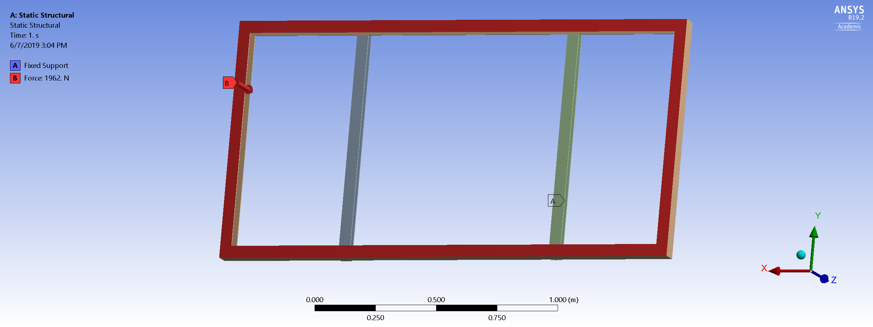
4.3 Integration Design

Figure 32: Solar Panel
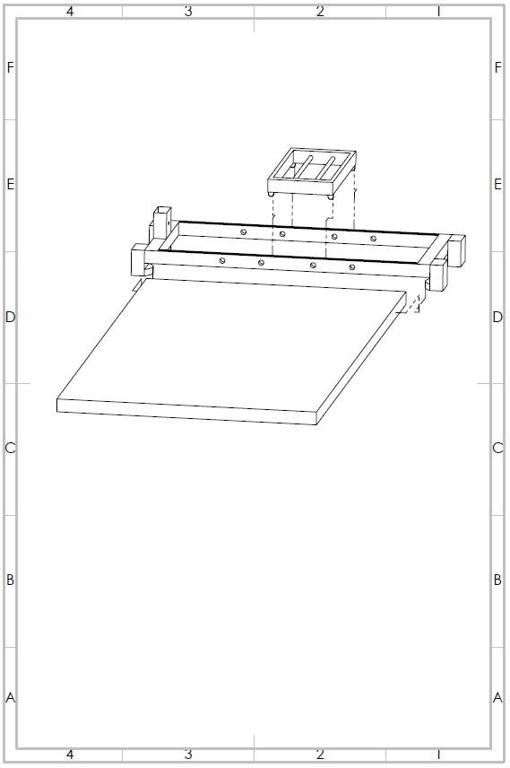

Figure 33: Design 1 (Dry)
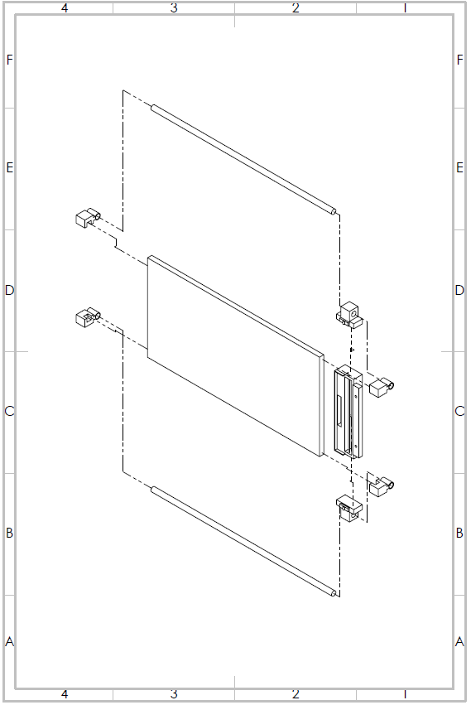
Figure 34: Design 2 (Wet and Dry)
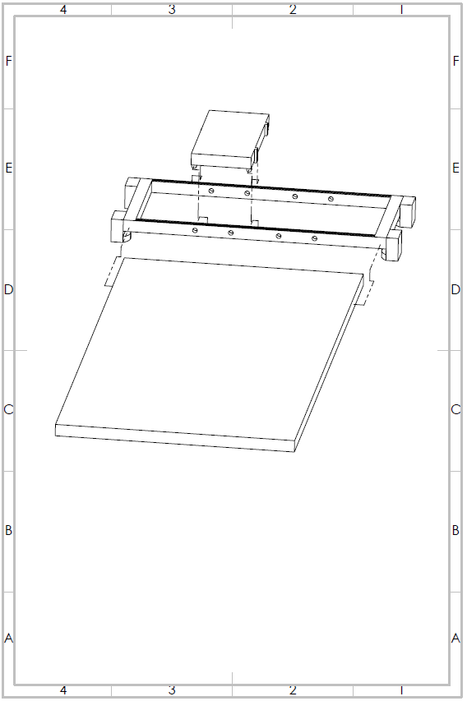
Figure 35: Design 3 (Ultrasonic)

4.4 Detailed Design
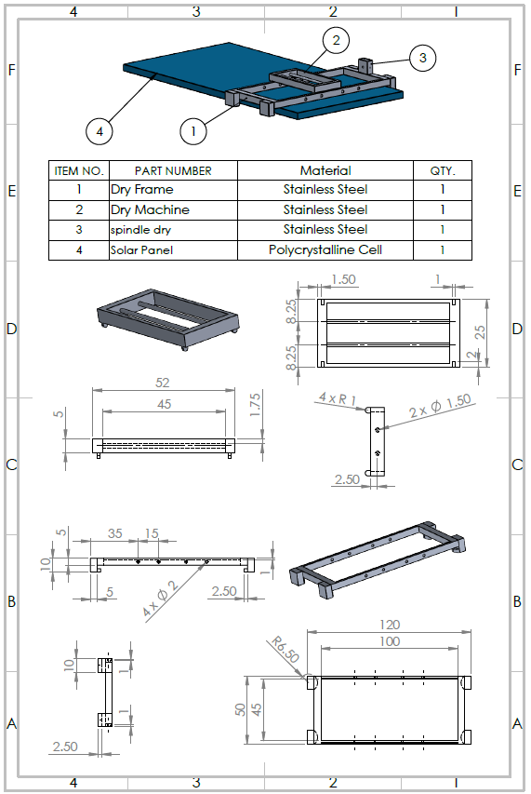
Figure 36: Engineering Drawing for Design 1 (Dry)

Table 8: Bill of Material for Design 1
No. | Material | Description
1 | Aluminium Frame (Body) | 0.13 m x 0.13m x 0.3 m
2 | Stainless Steel (Frame) | 0.008 m Dia. x 0.5 m
3 | Electrical Cable | 5 m
4 | DC motor | 12 V
5 | High Tension cable | Steel
6 | Roller Brush (Brush) | High Tensile Bristle
7 | Sensor | Ultrasonic
8 | Castor Wheel | 4.6 cm diameter

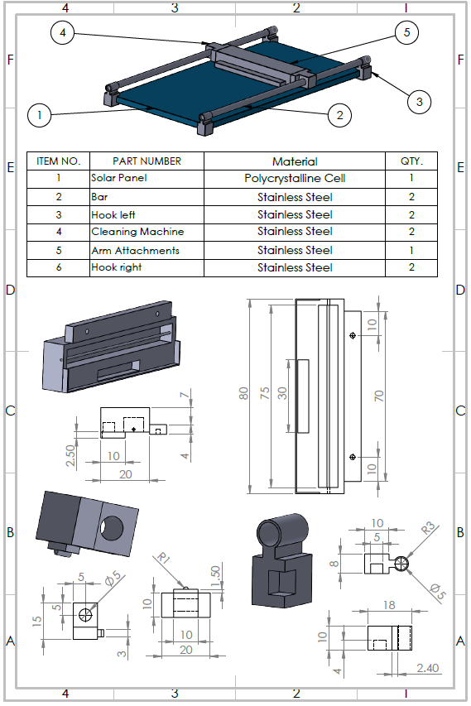
Figure 37: Engineering Drawing for Design 2 (Wet & Dry)

Table 9: Bill of Material for Design 2
No. | Material | Description
1 | Aluminium Frame (8m total) | 0.13 m x 0.13m x 0.3 m
2 | Stainless steel body | 0.5 m x 0.3m x 0.0005 m
3 | Electrical Cable (5m) | Old project / scrap = FOC
4 | 12V DC motor (x2) | Old project = FOC
5 | Roller Brush | High Tensile Brush
6 | Vacuum | Wet/ Dry Vacuum
7 | Sprinkler system (x2) | Low Pressure
8 | Castor wheel (x2) | 4.6 cm diameter
9 | Rubber Lip | Multi-Purpose Rubber Lip for Variety of Dirt
10 | Arduino | Motherboard
11 | Battery | 12V Lipo
12 | Lock | Aluminium

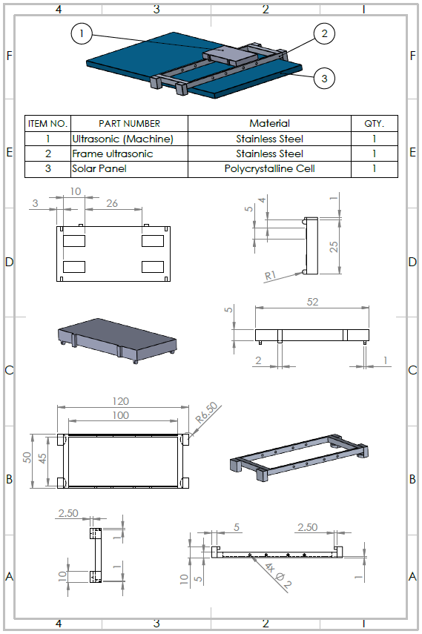
Figure 38: Engineering Drawing for Design 3 (Ultrasonic)

Table 10: Bill of Material for Design 3
No. | Material | Description
1 | Aluminium Frame (8m total) | 0.13 m x 0.13m x 0.3m
2 | Stainless steel body | 0.008 m Dia. x 0.5m
3 | Electrical Cable (5m) | 5 m
4 | 12V DC motor (x2) | 12V
5 | High tension cable (3m) | Steel
6 | Piezo transducer (x4) | Actuator
7 | Sprinkler system (x2) | Low Pressure
8 | Castor wheel (x8) | 4.6 cm diameter
9 | Sensor | Ultrasonic

5.0 ANALYSIS
With all the information (data) collected, in depth designs made and materials to be used decided by the team, analysis and tests were required to assist the team in deciding on one final design to be manufactured. Therefore, the team came up with 5 different analysis methods to be used on the 3 designs available to test their respective abilities. The methods were:
- Cost Analysis
- Business Value Analysis
- ANSYS Analysis
- Solidworks Analysis
- 3D Model Analysis
The content and results of each analysis are as follows.

5.1 COST ANALYSIS
There are a few main factors that all businesses have to take into consideration when making a purchase or investment. These factors are cost of the item, potential revenue brought in by the item and future outcome from buying the item (profit/ loss). Cost, in business terms, is defined as the value of expenditure in the form of money spent on items such as labour, equipment and rent in order for a business to function to its full ability. [28] Next, profit, also more commonly known as net profit, is the measure of a business’s earnings (excess money) after taking into account the all the costs and taxes involved. [29] On the other hand, loss occurs when a company’s expenditure outweighs its earnings. Furthermore, revenue is defined as the money a company earns from its usual business activities such as customer service, consultation and sales of goods. [29] In general, the formula used to calculate profit or loss is as shown below:

Total Revenue – Total Cost = +ve Value (Net Profit)/ -ve Value (Loss)…. [29]

With these factors in mind, the team decided to analyse our 3 designs by making a costing analysis for each of them. The purpose of this analysis was to determine which design had the fastest turnover time for the company (Fortune 11) to make a profit. In addition to this, the analysis conducted would also show which design made more profit or even a loss.
To begin analysing our designs, we first gathered information on the general costs incurred by Fortune 11 to maintain the solar panels using their own method which was by natural rain water. [30] They also used soap, water and brush/ mop to scrub the panels by manual labour to remove stubborn stains such as bird droppings and dry mud.
The in-depth calculation of all the costs involved are as shown in the table below. [30]
Table 11: Cost of Using Fortune 11’s Method of Maintaining Solar Panels (Based on Time)
Number of Workers | 10
Total Number of Solar Panels | 17120
Number of Available Working Days per Week | 5 days
Standard Working Hours per Day | 9 hours
Total Working Hours per Week | 45 hours per week
Cleaning Method Used | Manual (Water, soap, brush/ mop)
Time to Clean & Inspect 1 Panel | 1 minute 15 s
Number of Solar Panels in a Set (Row) | 40
Amount of Panels Cleaned & Inspected by 10 Workers in 5 minutes | 40 (4 panels per worker)
Number of Panels Cleaned & Inspected per Hour | 480 Panels per Hour
Number of Panels Cleaned and Inspected per Working Day | 4320 Panels per Day
Total Time Required to Clean & Inspect All Panels (1 cycle) | 4 days
Number of Cleaning Cycles in a Month | 5 cycles

Example Calculations for Table
Total working hours per week = 9 hours × 5 days
= 45 hours per week
Time to clean & inspect 1 panel per worker = 1.25 minutes
In 5 minutes, number of panels cleaned and inspected per worker = $\frac{5 minutes}{1.25 minutes per panel}$
= 4 panels
Amount of panels cleaned & inspected by 10 workers in 5 minutes = 10 workers × 4 panels
= 40 panels
Number of panels cleaned & inspected per hour = $\frac{60 minutes}{5 minutes} ×40 panels$
= 480 panels
Number of panels cleaned & inspected per working day = 480 panels × 9 hours
= 4320 panels
Total time required to clean & inspect all panels (1 cycle) = $\frac{17120 panels}{4320 panels per day}$
= 3.96 days
~ 4 days
Number of cleaning cycles in a month = $\frac{20 working days}{4 days per cycle}$
= 5 cycles per month

Table 12: Cost of Using Fortune 11’s Method of Maintaining Solar Panels (Based on Monetary Value), Split into 6 Types of Costing
a) Worker Cost
Cost per Worker | RM 60 per Day
Cost of 10 Worker’s Salary per Day | RM 600 per Day
Total Cost of 10 Worker’s Salary per Month  (5 working days, 4 weeks per month) | RM 12000 per Month

b) Soap Cost
Amount of Soap Used per Cycle | 171.2 kg
Amount of Soap Used per Month (5 cycles) | 856 kg
Cost of Soap (4 kg Packet from Lazada) | RM 22
Total Cost of Soap per Month | RM 4708

c) Water Cost
Amount of Water Used per Cycle | 1712 l
Amount of Water Used per Month (5 cycles) | 8560 l
Cost of Water per l  (Based on SYABAS Rates for Commercial Use) [31] | RM 2.07 per first 35 l  RM 2.28 above 35 l
Total Cost of Water per Month | RM 19509.45

d) Brush Cost
Amount of Brushes Used per Cycle | 171.2
Amount of Brushes Used per Month (5 cycle) | 856
Cost of Brushes (From Lazada) | RM 2 per Brush
Total Cost of Brushes per Month | RM 1712

e) Mop Cost
Number of Mops Used per Cycle | 2.4
Number of Mops Used per Month (5 cycle) | 17
Cost of Mops (From Lazada) | RM 10 per Mop
Total Cost of Mops per Month | RM 170

f) Total Cost
Total Monthly Cost (Expenditure) | RM 38059.45

Example Calculations for Table
a) Worker Cost
Cost per worker = RM 60 per day
Cost of 10 workers per day = RM 60 × 10 = RM 600
Cost of 10 workers per month = RM 600 × 20 = RM 12000
b) Soap Cost
1 small scoop of soap = ~ 100 grams
100 grams of soap can clean 10 panels
So, 100 panels require = 100 grams × 10 panels
= 1000 grams/ 1 kg of soap
Amount of soap required to clean all panels (1 cycle) = $\frac{17120 panels}{100 panels}$ × 1 kg
= 171.2 kg of soap
Amount of soap required for 5 cycles = 171.2 kg × 5 cycles = 856 kg
Cost of 4 kg soap from Lazada = RM 22
Total cost of soap per month = $\frac{856 kg}{4 kg} ×RM 22$ = RM 4708
c) Water Cost
1 l of water can clean = ~ 10 panels
10 l of water can clean = 10 panels $×$ 10 l = 100 panels
Amount of water required to clean all panels (1 cycle) = $\frac{17120 panels}{100 panels}$ × 10 l
= 1712 l
Amount of water required for 5 cycles = 1712 l × 5 cycles = 8560 l

Cost of Water per l (Based on SYABAS) = RM 2.07 per first 35 l, RM 2.28 above 35 l
Cost of water for first 35 l = RM 2.07 × 35 = RM 72.45
Cost of water above 35 l = (8560 l – 35 l) × RM 2.28 = RM 19437
Total cost of water per month = RM (72.45 + 19437) = RM 19509.45
d) Brush Cost
1 Brush can clean 100 panels
Amount of brushes required to clean all panels (1 cycle) = $\frac{17120 panels}{100 panels}$ × 1 brush
= 171.2 brushes
Amount of brushes required for 5 cycles = 171.2 brushes × 5 cycles = 856 brushes
Cost of 1 brush from Lazada = RM 2
Total cost of brushes per month = RM 2 × 856 brushes = RM 1712
e) Mop Cost
*mop used for panels placed at high/ hard to reach positions
1 mop can clean 5000 panels
Amount of mops required to clean all panels (1 cycle) = $\frac{17120 panels}{5000 panels}$ × 1 mop
= 3.4 mops
Amount of mops required for 5 cycles = 3.4 mops × 5 cycles = 17 mops
Cost of 1 mop from Lazada = RM 10
Total cost of mops per month = RM 10 × 17 mops = RM 170
f) Total Monthly Cost
RM (120 + 1712 + 19509.45 + 4708 + 12000) = RM 38049.45

With all the costs obtained, the team then calculated the total monthly revenue made by Fortune 11’s Solar Farm. This is as shown in the table below.
Table 13: Fortune 11’s Monthly Revenue
Total Electricity Generated by Solar Farm per day | 20 MWh
Total Electricity Generated by Solar Farm per Month (30 days) | 600 MWh
Rate TNB buys Electricity Produced by Fortune 11 Solar Farm  (Based on SEDA Malaysia’s set Feed-in Tariff, FiT) [32] | RM 0.544 per kWh  (For installed capacities above 10 MWh to 30 MWh)
Total Revenue of Fortune 11’s Solar Farm per Month | RM 326400

Example Calculations for Table
Total electricity generated per day = 20 MWh
Total electricity generated per month = 20 MWh × 30 days
= 600 MWh
Conversion from MWh to KWh = 600 MWh × ${10}^{3}$
= 600000 KWh
Rate TNB buys electricity produced by Solar Farms = RM 0.544 per KWh
Total revenue obtained by Fortune 11 = RM 0.544 per KWh × 600000 KWh
= RM 326400

Now that the team had Fortune 11’s monthly cost and revenue, we then calculated the monthly net profit and profit margin of the company.
Net profit = Total Revenue – Total Cost
= RM 326400 – RM 38049.45
= RM 288350.35
Profit Margin = $\frac{Net Profit}{Total Revenue}$× 100 %
= $\frac{RM 288350.35}{RM 326400}$× 100 %
= 88.34 %

From the detailed information of Fortune 11’s monthly expenditure (costs) and revenue, we then evaluated our 3 designs based on the costs involved. We then used the costs of each design and calculated the potential net profit and profit margin that each design could generate based on the constant revenue obtained by Fortune 11’s Solar Farm.
5.1.1 Design 1 (Dry Method)
All the potential costs involved are as shown in the tables below.
Table 14: Bill of Material to Build Design 1
Bill of Material
No. | Material | Description | Vendor | Unit Price (RM) | Quantity | Total (RM)
1 | Aluminium Frame | 0.13 m x 0.13m x 0.3 m | Lelong | RM 10/0.3m | 8 m | RM 270
2 | Stainless Steel | 0.008 m Dia. x 0.5 m | Lelong | RM 26.20/rod | 2 m | RM 52.40
3 | Electrical Cable | 5 m | Cytron Technologies | RM 2/m | 5 m | RM 10.00
4 | DC motor | 12 V | Old project  Or  Vendor | RM23/pc | 2 | RM 46.00
5 | High Tension cable | Steel | Alibaba | RM 0.21/m | 3 m | RM 0.63
6 | Roller Brush | High Tensile Bristle | Alibaba | RM 3.34 | 2 | RM 6.68
7 | Sensor | Ultrasonic | Lelong | RM 3.20 | 1 | RM 3.20
8 | Castor Wheel | 4.6 cm diameter | Lelong | RM 4 per pc | 8 | RM 32.00
Grand Total (RM) |  |  |  |  |  | RM 420.91

Table 15: Bill of Material for Monthly Maintenance of Design 1
Part | Quantity | Unit Price | Total Cost
Roller Brush | 2 | RM 3.34 | RM 6.68
Oil/ Lubricant for Motor (From Lazada) | 1 bottle | RM 115.00 | RM 115.00
Grand Total |  |  | RM 121.68

In order for this design to be able to clean all the solar panels for 5 cycles monthly, each row of solar panel has to have one autonomous solar panel cleaning robot of this design. However, since this design is able to move by itself or by human assistance, 20 of this design will be sufficient to get the job done. This is because after 20 rows are cleaned, the robots can be moved to clean the remaining 20 rows. Hence, the total monthly cost calculation are as follows:

Total monthly cost = (20 × Cost to build 1 unit) + (20 × Maintenance of 1 unit)
= (20 × RM 420.91) + (20 × RM 121.68)
= RM 10851.80

With the cost obtained, the potential monthly net profit and profit margin of this design is calculated as shown below:

Net profit = Total Revenue – Total Cost
= RM 326400 – RM 10851.80
= RM 315548.20
Profit Margin = $\frac{Net Profit}{Total Revenue}$× 100 %
= $\frac{RM 315548.20}{RM 326400}$× 100 %
= 96.68 %

5.1.2 Design 2 (Wet & Dry Method)
All the potential costs involved are as shown in the tables below.
Table 16: Bill of Material to Build Design 2
Bill of Material
No. | Material | Description | Vendor | Unit Price (RM) | Quantity | Total (RM)
1 | Aluminium Frame (8m total) | 0.13 m x 0.13m x 0.3 m  RM 10 per 0.3m  = RM 270  Or scrap metal  = FOC | Lelong | RM 10/0.3m | 8m | RM 270
2 | Stainless steel body | 0.5 m x 0.3m x 0.0005 m  = RM 136.55 x 2  = RM 273.10  Or Scrap metal = FOC | Rs comp. | RM 26.20/rod | 2m | RM 52.40
3 | Electrical Cable (5m) | Old project / scrap = FOC | Cytron Technologies | RM 2/m | 5 m | RM 10
4 | 12V DC motor (x2) | Old project = FOC  Pudu shop  = RM 23 | Old project  Or  Vendor | RM 23/pc | 2 | RM 46
5 | Roller Brush | RM 3.34 per pc | Alibaba | RM 3.34 | 1 | RM 3.34
6 | Vacuum | Wet/ Dry Vacuum | Karcher | RM 900 | 1 | RM 300
7 | Sprinkler system (x2) | Low Pressure | Lelong | RM 15 | 2 | RM 30
8 | Castor wheel (x2) | 4.6 cm diameter  RM 16 per 4pc  = RM 8 | Lelong | RM 4 per pc | 2 | RM 8
9 | Rubber Lip | Multi-Purpose Rubber Lip for Variety of Dirt | Karcher | RM 47.29 | 2 | RM 94.58
10 | Arduino | Motherboard | Cytron | RM 96 | 1 | RM 96
11 | Battery | 12V Lipo | Cytron | RM 12.50 | 1 | RM 12.50
12 | Lock | Lock Plate Set | Rs comp. | RM 20.24 | 1 | RM 20.24
Grand Total (RM) |  |  |  |  |  | RM 943.06

Table 17: Bill of Material for Monthly Maintenance of Design 2
Part | Quantity | Unit Price | Total Cost
Roller Brush | 2 | RM 3.34 | RM 6.68
Oil/ Lubricant for Motor (From Lazada) | 1 bottle | RM 115.00 | RM 115.00
Vacuum Service (After 1 year warranty by Karcher) | Once Monthly | RM 40 | RM 40
Rubber Lip  (After 1 year warranty by Karcher) | 2 pieces | RM 47.29 | RM 94.58
Water (Able to be recycled) | 214 l | RM 2.07 per first 35 l  RM 2.28 above 35 l | RM 480.57
Soap (Able to be recycled) | 21.4 kg | RM 5.5 per kg | RM 117.70
Grand Total |  |  | RM 854.53

In order for this design to be able to clean all the solar panels for 5 cycles monthly, each row of solar panel has to have one autonomous solar panel cleaning robot of this design. However, since this design is able to move by itself or by human assistance, 20 of this design will be sufficient to get the job done. This is because after 20 rows are cleaned, the robots can be moved to clean the remaining 20 rows. Hence, the total monthly cost calculation are as follows:

Total monthly cost = (20 × Cost to build 1 unit) + (20 × Maintenance of 1 unit)
= (20 × RM 943.06) + (20 × RM 854.43)
= RM 35949.80

With the cost obtained, the potential monthly net profit and profit margin of this design is calculated as shown below:

Net profit = Total Revenue – Total Cost
= RM 326400 – RM 35949.80
= RM 290450.20
Profit Margin = $\frac{Net Profit}{Total Revenue}$× 100 %
= $\frac{RM 290450.20}{RM 326400}$× 100 %
= 89 %

5.1.3 Design 3 (Ultrasonic Method)
Table 18: Bill of Material to Build Design 3
Bill of Material
No. | Material | Description | Vendor | Unit Price (RM) | Quantity | Total (RM)
1 | Aluminium Frame (8m total) | 0.13 m x 0.13m x 0.3m | Lelong | Rm10/0.3m | 8m | RM 270
2 | Stainless steel body | 0.008 m Dia. x 0.5m | Lelong | Rm26.20/rod | 2m | RM 52.40
3 | Electrical Cable (5m) | 5 m | Cytron Technologies | RM 2/m | 5 m | RM 10
4 | 12V DC motor (x2) | 12V | Old project  Or  Vendor | RM23/pc | 2 | RM 46
5 | High tension cable (3m) | Steel | Alibaba | RM0.21/m | 3m | RM 0.63
6 | Piezo transducer (x4) | Actuator | Element14 | RM2.94 | 4 | RM 11.76
7 | Sprinkler system (x2) | Low Pressure | Lelong | RM15 per pc | 2 | RM 30
8 | Castor wheel (x8) | 4.6 cm diameter | Lelong | RM4 per pc | 8 | RM 32
9 | Sensor | Ultrasonic | Lelong | RM3.20 | 2 | RM 6.40
Grand Total (RM) |  |  |  |  |  | RM 459.19

Table 19: Bill of Material for Monthly Maintenance of Design 3
Part | Quantity | Unit Price | Total Cost
Piezo transducer | 4 | RM 2.94 | RM 11.76
Oil/ Lubricant for Motor (From Lazada) | 1 bottle | RM 115.00 | RM 115.00
Grand Total |  |  | RM 126.76

In order for this design to be able to clean all the solar panels for 5 cycles monthly, each row of solar panel has to have one autonomous solar panel cleaning robot of this design. However, since this design is able to move by itself or by human assistance, 20 of this design will be sufficient to get the job done. This is because after 20 rows are cleaned, the robots can be moved to clean the remaining 20 rows. Hence, the total monthly cost calculation are as follows:

Total monthly cost = (20 × Cost to build 1 unit) + (20 × Maintenance of 1 unit)
= (20 × RM 459.19) + (20 × RM 126.76)
= RM 11719

With the cost obtained, the potential monthly net profit and profit margin of this design is calculated as shown below:

Net profit = Total Revenue – Total Cost
= RM 326400 – RM 11719
= RM 314681
Profit Margin = $\frac{Net Profit}{Total Revenue}$× 100 %
= $\frac{RM 314681}{RM 326400}$× 100 %
= 96.41 %

5.1.4 Conclusion from Analysis
From the evaluation carried out by the team, it can be seen that all 3 designs had better monthly net profits and profit margins as compared to the current method of cleaning solar panels used by Fortune 11.
When comparing the 3 designs, it can also be seen that Design 1 had the highest profit margin followed by Design 3. On the other hand, Design 2 had the lowest profit margin. Therefore, in terms of costing, Design 1 was the best design due to its cost efficiency.

5.2 BUSINESS VALUE ANALYSIS
Business value has various definitions, but can be generally defined as the net benefit to the client of a project measured in monetary or non-monetary terms. [33] In this case, the client is Tenaga Nasional Berhad. Business value also determines the well-being of the business in the long run. Hence, this analysis will cover the non-monetary benefits in the first half and the monetary advantages in the second half.

The conversion of energy can drop by up to 30 % due to the panels being dirty. [34] This is because the build-up of contaminants clouds the solar panel surface and decreases the amount of light reaching the solar cells. In Fortune 11 solar farm, dust, mud and bird droppings are the main contaminant types. Their current approach to cleaning the solar panels is primarily through natural rain. However, this method is ineffective since the occurrence of rain is unpredictable and rain (specifically light rain) is unable to completely remove contaminants. Moreover, rain itself contains some dust particles that attach to the solar panel surface once the water evaporates.

During insufficient rainy periods, the panels are cleaned manually by mopping with soap and water. Although this practice is relatively inexpensive, it is inefficient as it is time-consuming and requires a lot of human effort. There is also a risk of accidents, especially in the case of solar panels that are installed at a certain height. Besides, this method results in high water wastage since a lot of water is used to wash away soap from the panels. On top of that, manual cleaning may even decrease solar panel efficiency in the long run. Humans do not always exert an equal amount of pressure with a mop on a solar panel surface. Too high pressure can damage the panels at most [35] while too low pressure cannot thoroughly clean the panels. Any wrong or sudden movements may cause scratches that cast shadows and affect power production. [36]

On the other hand, professional cleaning can yield up to 12 % more output as opposed to those cleaned by rain water. [37] Hence, the proposed solution was an automatic solar panel cleaner. This method requires minimal labour; only to mount/dismount the robots onto each solar panel row. Thus, the risk of accidents is significantly lesser. The overall cleaning time is also reduced since the robots work on all solar panel rows simultaneously and have constant speeds throughout. Furthermore, Design 1 did not require the use of water while Designs 2 and 3 can be made to use a minimal amount of water. This ensures little to no water wastage during the cleaning process.
All the proposed automatic cleaners are to be equipped with cleaning tools that are used to clean stubborn stains without putting immense pressure on the solar panels. For instance, the brushes in Design 1 comes into contact with the solar panel surface, just enough to sweep off contaminants and maintains the same distance and even pressure the entire process. Additionally, the automatic cleaners are created to adapt to the shifting angles of the solar panels as they are securely fixed to the sides of the solar panel row when mounted. As the designs may potentially have their own dirt tracking systems, the need for visual inspection can also be eliminated.

Another major advantage is the business value gain (monetary) of the proposed solution. As a corporate company/organisation, whether or not the business/solution is sustainable or “worth it” in financial terms is an important issue to be considered. Hence, the team conducted calculations to show that the proposed designs improved financial returns/savings. The main table that organises the following data is on page 67. Formulas for business value gain and annual savings were obtained from a previously-taken module, Business Skills for Engineers, taught by lecturer, Dr. Felicia Wong Yen Myan.

5.2.1 Sample Calculations for Monthly/Annual Expenditures
Referring to the values from the previous Cost Analysis section;

5.2.1.1 Conventional method (manual mopping)

a. Labour Cost = RM 12 000.00
b. Maintenance Cost = Soap Cost + Water Cost + Brush Cost + Mop Cost
= RM 4 708 + RM 19 509.45 + RM 1 712 + RM 170
= RM 26 099.45
c. Total Monthly Expenditure = Labour Cost + Maintenance Cost
= RM 12 000.00 + RM 26 099.45
= RM 38 059.45
d. Total Annual Expenditure = Total Monthly Expenditure x 12 months
= RM 38 059.45 x 12
= RM 457 193.40

Referring to the previous Cost Analysis section, it is assumed that a total of 20 cleaning machines will be manufactured for each design. Hence;

5.2.1.2 Design 1 (Dry Method)

a. Manufacturing/Implementation Cost = RM 420.91
b. Maintenance Cost = RM 121.68
c. Total Expenditure for First Month = (20 × Cost to build 1 unit) + (20 × Maintenance of 1 unit)
= (20 × RM 420.91) + (20 × RM 121.68)
= RM 10 851.80
d. Total Annual Expenditure = (Total expenditure for first month) +
(Total expenditure for the remaining 11 months)
= RM 10 851.80 + (20 units x RM 121.68 x 11 months)
= RM 10 851.80 + RM 26 769.60
= RM 37 621.40

5.2.1.3 Design 2 (Wet and Dry Method)

a. Manufacturing/Implementation Cost = RM943.06
b. Maintenance Cost = RM854.53
c. Total Expenditure for First Month = (20 × Cost to build 1 unit) + (20 × Maintenance of 1 unit)
= (20 × RM 943.06) + (20 × RM 854.43)
= RM 35 949.80
d. Total Annual Expenditure = (Total expenditure for first month) +
(Total expenditure for the remaining 11 months)
= RM 35 949.80 + (20 units x RM 854.43 x 11 months)
= RM 35 949.80 + RM 187 974.60
= RM 223 924.40

5.2.1.4 Design 3 (Ultrasonic Method)

a. Manufacturing/Implementation Cost = RM 459.19
b. Maintenance Cost = RM126.76
c. Total Expenditure for First Month = (20 × Cost to build 1 unit) + (20 × Maintenance of 1 unit)
= (20 × RM 459.19) + (20 × RM 126.76)
= RM 11719.00
d. Total Annual Expenditure = (Total expenditure for first month) +
(Total expenditure for the remaining 11 months)
= RM 11 719.00 + (20 x RM 126.76 x 11 months)
= RM 11 719.00 + RM 27 887.20
= RM 39 606.20

5.2.2 Sample Calculations for Business Value Gain

5.2.2.1 Design 1
Table 20: Business Value for Design 1
 | Conventional Method | Design 1
Total Annual Cost | RM 457 193.40 | RM 37 621.40

Business Value Gain = Annual cost of conventional method - Annual cost of Design 1
= RM 457 193.40 - RM 37 621.40
= RM 419 572.00

5.2.2.2 Design 2
Table 21: Business Value for Design 2
 | Conventional Method | Design 2
Total Annual Cost | RM 457 193.40 | RM 223 924.40

Business Value Gain = Annual cost of conventional method - Annual cost of Design 2
= RM 457 193.40 - RM 223 924.40
= RM 233 269.00

5.2.2.3 Design 3
Table 22: Business Value for Design 3
 | Conventional Method | Design 3
Total Annual Cost | RM 457 193.40 | RM 39 606.20

Business Value Gain = Annual cost of conventional method - Annual cost of Design 3
= RM 457 193.40 - RM 39 606.20
= RM 417 587.20

5.2.3 Sample Calculations for Annual Savings
% Savings per annum = $\frac{\left(Business Value Gain\right)}{Cost of Conventional Method}$
1) Annual savings for Design 1 = $RM\frac{419572}{457193.40}$x 100%
= 91.7 %

2) Annual savings for Design 2 = $RM\frac{233269}{457193.40} x$ 100%
= 51.02 %

3) Annual savings for Design 3 = $RM\frac{417587.20}{457193.40} x$ 100%
= 91.34 %

5.2.4 Sample Calculations for Return of Investment (ROI)
Return of Investment, ROI = $\frac{Investment}{Business Value}$
1) Return of Investment for Design 1 = $RM\frac{37621.40}{419572.00}$
= 0.08967 x 365 days
= 32.73
≃ 33 days

2) Return of Investment for Design 2 = $RM\frac{223924.40}{233 269.00}$
= 0.08967 x 365 days
= 350.38
≃ 351 days

3) Return of Investment for Design 3 = $RM\frac{39606.20}{417587.20}$
= 0.09485 x 365 days
= 34.62
≃ 35 days

5.2.5 Business Value Summary
Table 23: Comparison of all methods
 | Conventional | Design 1 | Design 2 | Design 3
Monthly Labour Cost (RM) | RM 12 000.00 | - | - | -
Monthly Manufacturing Cost (RM) | - | RM 420.91 | RM 943.06 | RM 459.19
Monthly Maintenance Cost (RM) | RM 26 099.45 | RM 121.68 | RM 854.53 | RM 126.76
Total Monthly Expenditure (RM) | RM 38 059.45 | RM 10 851.80 | RM 35 949.80 | RM 11 719.00
Total Annual Expenditure (RM) | RM 457 193.40 | RM 37 621.40 | RM 223 924.40 | RM 39 606.20
Business Value Gain (RM per year) | - | RM 419 572.00 | RM 233 269.00 | RM 417 587.20
Annual Savings (%) | - | 91.70 % | 51.02 % | 91.34 %
Return of Investment (Days) | - | 33 days | 351 days | 35 days

Based on Table 17, the business value gain for all 3 designs are a significant amount specifically for Designs 1 and 3. As a result, their annual savings are also high; all surpassing the 50% mark. Although these automatic solutions come with initial cost (manufacturing /implementation cost), they prove to be a better investment in the long run due to their relatively lower monthly maintenance cost. This reinforces the advantage of these automatic solar panel cleaner designs on top of all the other ones mentioned before.

Among the 3 designs, Design 1 has the highest business value gain and annual savings followed by Design 3 and Design 2. This is mainly because Design 1 is focused only on brushing off contaminants and does not require water. It is important to note that although Design 1 leads the rest in terms of business value, Design 2 is expected to be more effective in cleaning the solar panels because it incorporates water, brush and vacuum.
5.3 ANSYS SIMULATION

5.3.1 SOLAR PANEL

The Solar panel is mounted onto a frame where the supports are attached to it. The frame is made from aluminium alloy with Yield strength of 50 MPa and Ultimate Strength of 90 MPa. When a force of 1962N (200kg) is acting on the panel frame, it results in a stress of about 10.5 MPa. The stress analysis is shown below.

Figure 39: Setup of the Ansys Stress test for the Solar panel frame

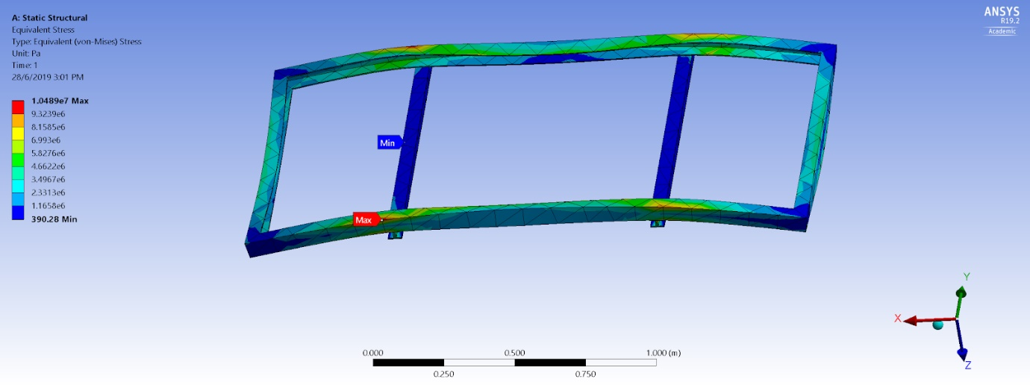
Figure 40: Ansys Stress analysis of solar panel frame

5.3.2 Design 1
An estimate of 20kg is allocated for the dry cleaner and applied onto the tracks of the frame. With the side of the frame set as the fixed support, the 20kg weight is translated to about 196.2N of force. The stress amounts to about 6.55x10^5 Pa or 0.66 MPa.

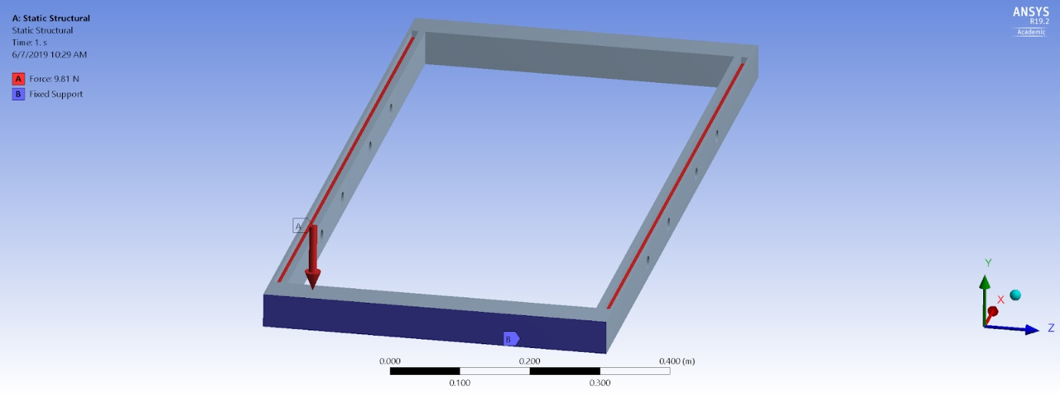
Figure 41: Setup of the Ansys Stress test for design 1

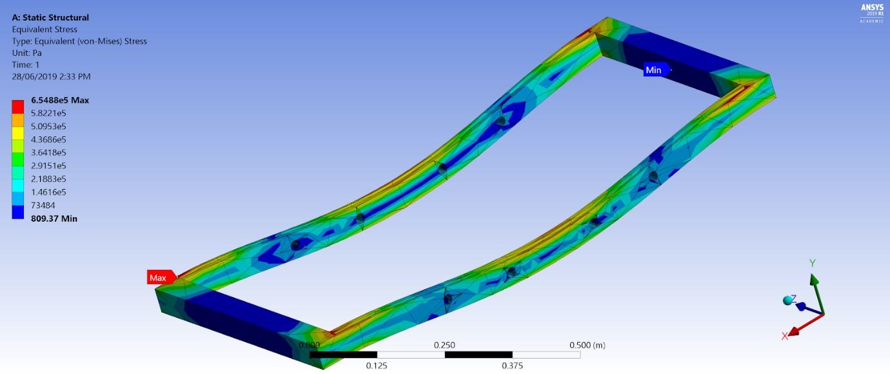
Figure 42: Ansys Stress analysis of Design 1 frame

5.3.3 Design 2
An estimate of 40kg is allocated for the wet dry cleaner and the weight distributed among the 2 bars would result in the stress divided between the 2 bars. With the locks at the edges set as the fixed support, the 40kg weight divided into 2 which is translated to about 196.2N of force on each side. The stress amounts to about 9.59x10^5 Pa or 0.96 MPa.

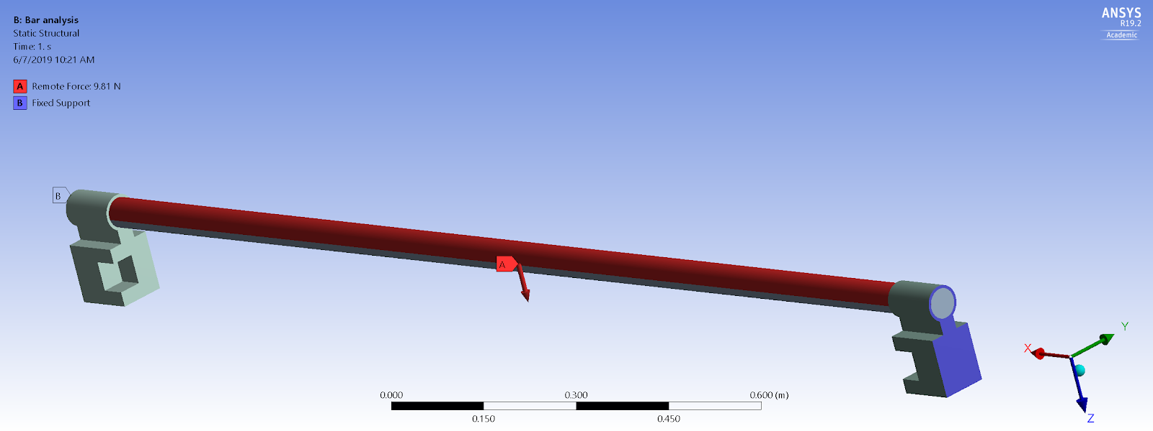
Figure 43: Setup of the Ansys Stress test for design 2
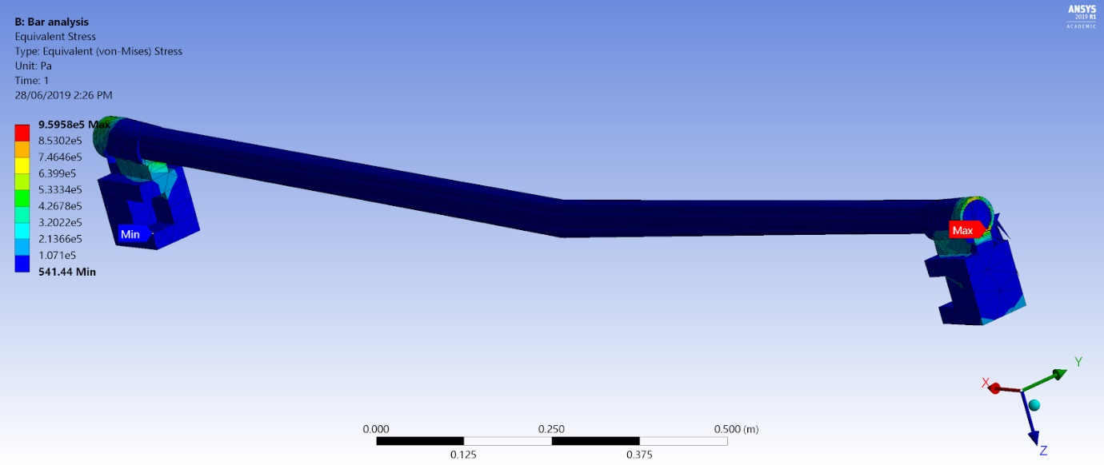
Figure 44: Ansys Stress analysis of Design 2 bars

5.3.4 Design 3
An estimate of 25kg is allocated for the ultrasonic cleaner and applied onto the tracks of the frame. With the side of the frame set as the fixed support, the 25kg weight is translated to about 245.25N of force. The stress amounts to about 8.19x10^5 Pa or 0.82 MPa.

Figure 45: Setup of the Ansys Stress test for design 3

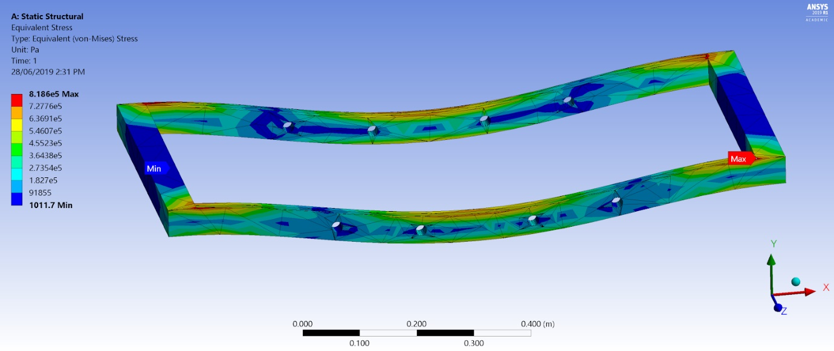
Figure 46: Ansys Stress analysis of Design 3 frame

The results from the ANSYS analysis is compiled into the table as shown below. Based on this table, the dry cleaner (design 1) seems to have the least amount of stress followed by ultrasonic cleaner (design 3) and then the wet dry cleaner (design 2). Besides that, all 3 designs are suitable to be mounted on the solar panel without deforming it as the weight for all 3 designs does not exert stress above 10.5MPa and therefore won’t deform the frame of the solar panel and damage the solar panel.

Table 24: Ansys Stress analysis data
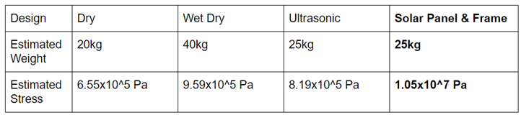

5.4 SOLIDWORKS SIMULATION

After completing the ANSYS simulations for all three designs, we implemented Solidworks simulations to carry out how each and every design would carry out its maintenance for a solar panel. Design 1 and Design 3 would carry out its cleaning methods within a time of 55 seconds for a single panel which would in turn take roughly 45 minutes to clean a whole table of 20 panels. Furthermore, Design 2 only take 45 seconds to clean a single panel which would mean that a whole table of 20 panels would take roughly 40 minutes which is significantly less than Design 1 and 3. This is due to the theory that with less moving parts or links suchs as binary, ternary and quaternary links, it would take less amount of power for movement as well as less amount of maintenance for the overall design in Design 2. [38] To find the numbers of links within a body on degress of freedom, we applied Grubler’s equation. [39]
$$F=3\left(n-1\right)-2j{}_{1}-j_{2}$$
F = Mobility or number of degrees of freedom
n = Number of links including frame
j₁ = Joints with single or one degree of freedom
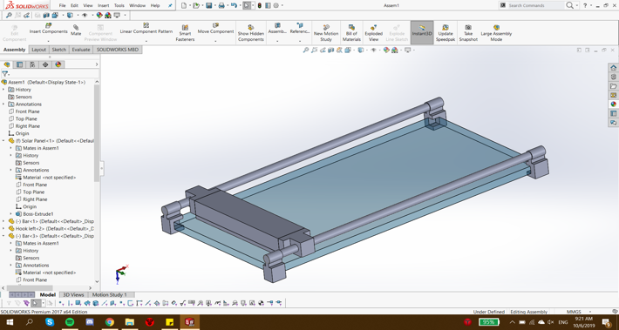
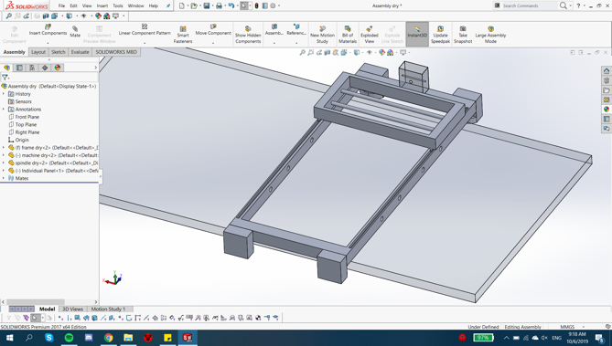
j₂ = joints with two degrees of freedom
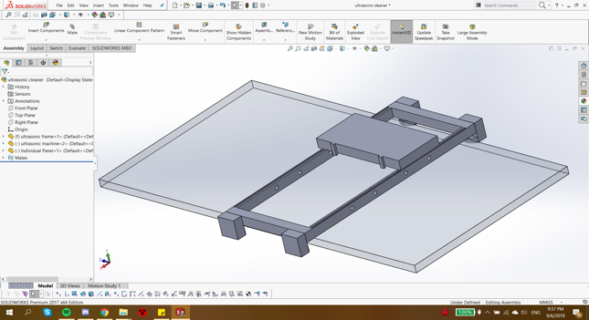
Figure 47: Design 1 Dry Method Figure 48: Design 2 Wet & Dry Method

Figure 49: Design 3 Ultrasonic Method

5.5 3D MODELLING ANALYSIS
To get a clearer picture on how the designs would fit onto and move along the solar panels, scaled-down models of the solar panel and all 3 designs were 3D-printed. Certain parts and minor details of the designs had to be simplified or omitted in the printed models due to the size limitations and nature of the 3D printer.

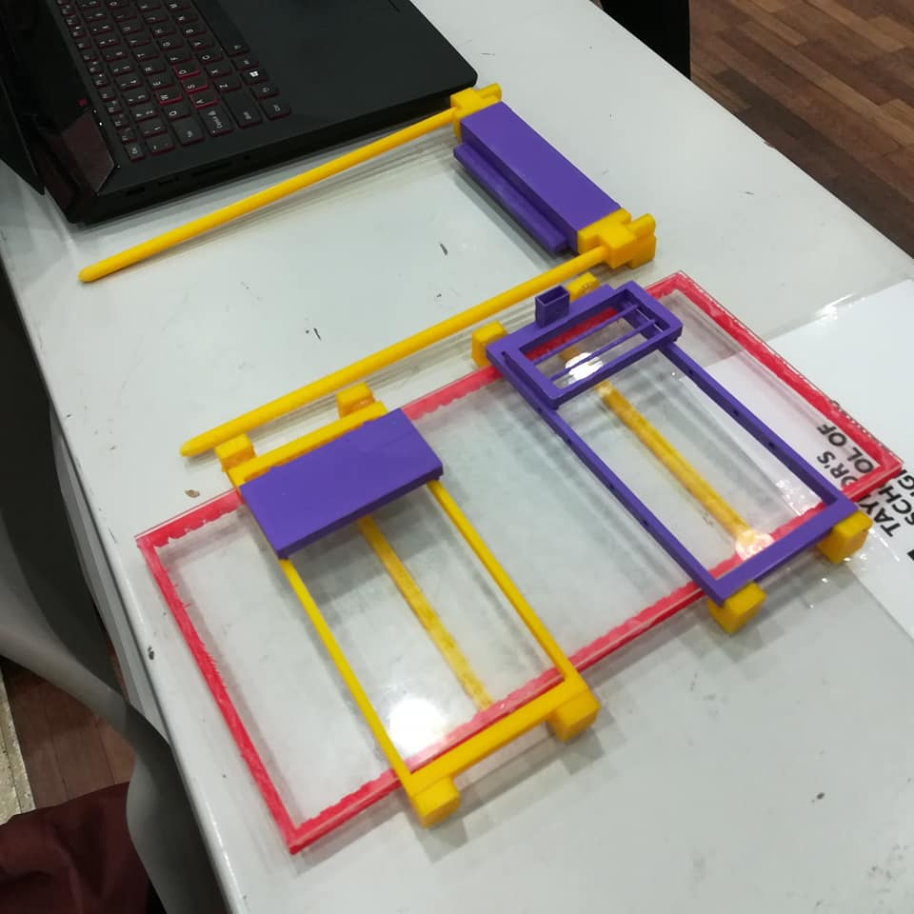
Figure 50: Overview of All Assembled 3D Models

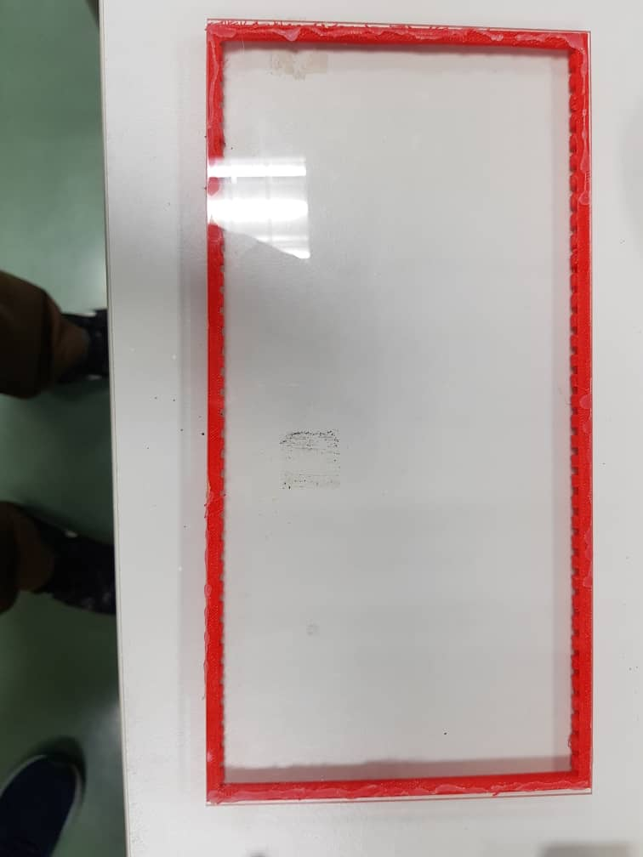
Figure 51: 3D Model of Solar Panel

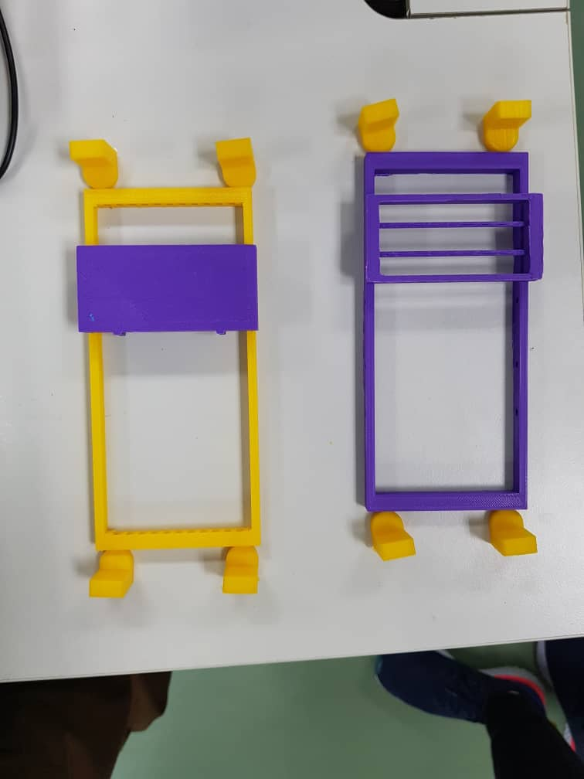
Figure 52: 3D Models of Design 1 (Right) and Design 3 (Left)

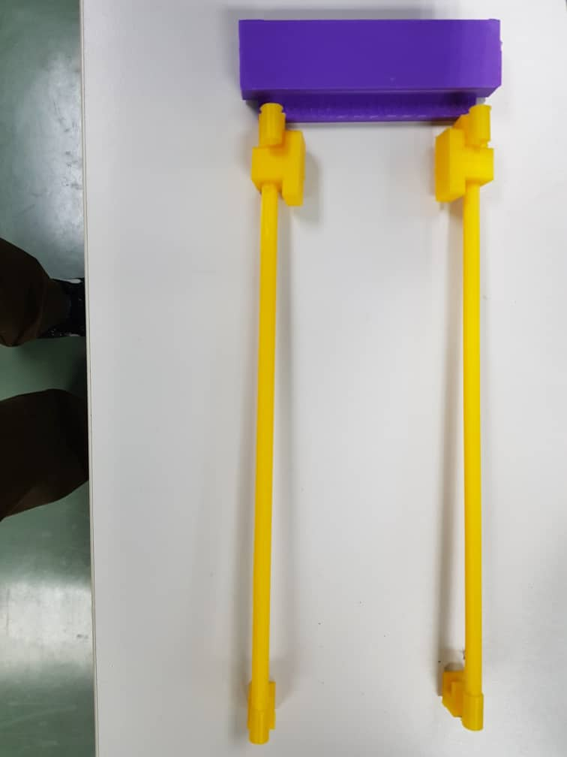
Figure 53: 3D Model of Design 2

After testing the small-scale mock-up, the designs were found to be easy to manoeuvre in addition to being aesthetically pleasing.

6.0 SUSTAINABILITY
6.1 ECONOMIC VIABILITY
A viable business is one that can sustain profit over the years. [40] Based on the cost profit analysis, this was demonstrated by the monthly net profit margin all surpassing at least 88% after the implementation of any of the 3 designs. This is due to the stark difference in monthly expenditure between the conventional method and proposed designs. While Design 1 did not require water at all, designs 2 and 3 did require a small amount of it but they ultimately used substantially less water and soap than manual mopping. Aside from that, less human workers will be needed since the designs were mostly automated. Hence, all these expenses will be greatly lowered. Overall cleaning time will also be reduced, thus increasing productivity. Apart from that, the building materials are of a reasonable cost but most importantly, they are of high quality to ensure durability. This means that there will not be a need to frequently replace or perform major repairs on parts, just occasional maintenance. Lastly, the business value analysis had proven that the proposed designs came with significant annual savings and return of investment.

6.2 SOCIALLY ACCEPTABLE/ RESPONSIBLE
In the social aspect, the product should prioritise safety and convenience of the user. The conventional cleaning method required staff to work under the constant glare and heat from the sun for long hours which may lead to cases of dehydration, fatigue, heat stroke and other long-term health side effects. Meanwhile, the automated cleaners were able to alleviate the burden of Fortune 11 solar farm’s staff due to the minimal need for human labour. Besides that, the proposed designs were generally harmless to users since they were mostly automated. The only precautionary steps to take were during the transportation of the robot and during operation where a safe distance between the user and the robot is advised. Other than that, each design had a good user interface and was ethical in terms of adhering to national and international standards for products of the similar range.

6.3 ENVIRONMENTALLY FRIENDLY
All 3 designs were devised with their environmental impact in mind. Since the robots only required a power source and minimal amount of water at most to operate, they will not emit toxic waste or any harmful by-products. For Designs 2 and 3 which involved water as input, they required much less water as compared to the conventional cleaning method used by Fortune 11. In addition, there was a potential for the practice of reusing water in the future which will help in the fight against resource depletion. Moreover, the surrounding landscape or solar farm site would not be affected as the robots will not be fixed to the ground. Instead, the robots are portable and simply mounted on or dismounted from the solar panels. Furthermore, the solar panel cleaners indirectly improved the generation of solar power which is a clean energy source. As mentioned in the analysis section, the conversion of energy can drop due to unwashed panels. Hence, the robots promoted renewable energy in a way, by keeping solar panels at their best level of efficiency.

6.4 TECHNOLOGICALLY FEASIBLE
Resulting from the initial research findings as included in the Interim Report, the 3 designs each incorporated one or more attributes of the currently available solar panel cleaning solutions. Hence, they are feasible in terms of the technology required to manufacture, operate and maintain them. This includes the materials, production processes, and mechanism in regard to the cleaning, motion and control subsystems.

7.0 BUSINESS PLAN
7.1 COST VALUE
Table 25: Monthly Net Profit and Profit Margin for all cleaning methods
Method of Cleaning | Monthly Net Profit | Monthly Profit Margin
Fortune 11 | RM 288350.35 | 88.34 %
Dry Method (Design 1) | RM 315548.20 | 96.68 %
Wet & Dry Method  (Design 2) | RM 290450.20 | 89 %
Ultrasonic Method  (Design 3) | RM 314681.00 | 96.41 %

7.2 BUSINESS VALUE
Table 26: Business value, annual savings and return of investment for all methods
 | Conventional | Design 1 | Design 2 | Design 3
Business Value Gain (RM per year) | - | RM 419 572.00 | RM 233 269.00 | RM 417 587.20
Annual Savings (%) | - | 91.70 % | 51.02 % | 91.34 %
Return of Investment (Days) | - | 33 days | 351 days | 35 days

Based on Table 26 shown above, Design 1 gave the highest business value gain and annual savings which led to the best return of investment followed by Design 3 and Design 2.

In this case, Design 1 had the best return of investment (ROI) since the investors/users only required 33 days to obtain back the money they invested in this design. Design 2 also gave a considerable ROI of only 35 days. However, Design 2 had a defeat to the rest where it exceeded the ROI of Design 1 and 3 by 10 times. Since ROI evaluates the efficiency of user when it comes to investing in a product, therefore Design 1 gave the best impression to investors/users compared to the other designs.

However, efficiency of a product also plays a big role when it comes to investing in a product. In this matter, Design 2 dominated the rest in terms of efficiency. The reason being was that Design 2 incorporated brushes, water and vacuum which had more functions in its cleaning system compared to Design 1 which only relies on brushes without water in the cleaning process. On the other hand, Design 3 used ultrasonic cleaning technology which is inconsistent as it is not capable of removing the stubborn dirt such as the bird droppings.

By choosing a product which has a good ROI without taking into consideration its efficiency, a problem might be created in the long run. For instance, when the efficiency of a product is bad, the product requires more effort to operate and hence it requires more maintenance work to be done. After several researches and studies were conducted by the team, it was found that investing in a more effective cleaning robot (Design 2) would be necessary as this will benefit the user in a long term run.

7.3 6P’s
The 6P’s in business are the formula of marketing tactics to meet customer needs and covers Premise, Processes, Production, People, Price, and Promotion. [40] A strategic premise is crucial in a successful business. Since this business focuses mainly on manufacturing, delivery and maintenance, it is preferable to have a location closer to industrial sites which have roads easily connected to the location of the client or solar farms. This reduces transportation costs and maximises profit. The premise should also have a decent amount of space sufficient to accommodate 4 sections; showroom, office and R&D department, production line and warehouse.

As for the processes and production aspect, the logistics for this product include the manufacturing and assembly of subsystems, quality control, testing, storage, packaging and transportation. This would require a number of tools and heavy machinery, although some components can be sourced externally. This is where the people aspect also comes into play, because a structured organisation or assignment of roles is essential in keeping the business running smoothly. There should be multiple departments each responsible for a specific need such as finance, R&D, sales and marketing, production line (includes all activities mentioned in the production aspect), and human resources.

The price aspect covers not only the manufacturing and part maintenance costs (refer to cost analysis), but also concerns operating and non-operating costs. Operating costs include rent, equipment, wages, inventory costs, and allocated R&D funds while non-operating costs include interest and taxes. A business thrives on customers or demand, which is why promotion is necessary to make the brand known and expand the business. In the early stages of the business, inexpensive methods of marketing may be sufficient such as through social media, reviews from influential figures, and word-of-mouth. Once the business has expanded, effective outreach strategies may include product showcases, conferences, billboard advertising, advertisements, and global ambassadors.

In the case of our designs, the knowledge of each of the 6P’s were applied to further enhance the business appeal of our products to potential partners and/ or investors. In terms of premise, all of the team’s designs were made in a way that they would be able to be manufactured locally using the technology readily available. With this application, the delivery and maintenance of the team’s products will be much easier as the distance from the factories and offices to the client’s location is shorter due to the team’s product being locally manufactured. For the processes and production involved in making our products, the designs created were made up of as little moving parts as possible. This is due to the team’s knowledge in Theory of Machines and Mechanisms whereby, the lesser the amount of moving parts, the lower the potential for joints to spoil. Hence, less maintenance. In addition to that, each design was made so that it could be easily produced and manufactured by other people (factories) without the need of the team overseeing every process involved.

Furthermore, the people aspect was also taken into consideration by the team. For example, in order for the designs to be made at the highest level of quality possible, the team agreed that experts were required in the quality control side of production. In short, people who were properly and specifically trained were required in each department of manufacturing such as finance, R & D and sales in order for the team’s designs to be made successfully. In terms of price, the team ensured that each design not only cost little to produce but also had low monthly maintenance cost. This was made possible due to the team choosing quality parts and also cheaper alternatives that had the same standard as expensive materials. In addition, the overall cost to produce the designs was low because of the designs being able to be produced locally.

As for the promotion of the designs to the current market, the team believed that by working with well-known companies such as TNB, Fortune 11 and potentially Karcher Malaysia, the products manufactured would gain interest at a high rate due to these companies being well established in the Malaysian market. Hence, increasing the team’s brand exposure with a working, cost efficient and one of a kind autonomous solar panel cleaning robot.

8.0 CONCLUSION & RECOMMENDATIONS
In summary, this report not only acts as a continuation to the first interim report made but also as a closure to all the research done, information gathered, designs created and analysis carried out. With this report, the team now has a better and clearer idea of how the final design to be manufactured next semester would look like. Before any designs were made, the team kept in mind of the criterion given by IR Rhaiz from TNB regarding the requirements of building an autonomous solar panel cleaning robot. The criterion were:
- Effective and efficient
- Lightweight and easy-to-use
- Low cost and maintenance
- Adaptable to shifting arrangements of solar panels
- Flexibility in cleaning various types of contaminants
- Has its own dirt tracking system

Based on the criterion stated above, the team then moved on to the Conceive stage of the CDIO method. [6] The team applied this method as it is a crucial guideline for any engineering projects. Therefore, in this stage, the team carried out intensive research on current cleaning methods of solar panels being used by solar farms and companies in the market. In addition to that, the team also gathered information on TNB, Fortune 11’s solar farm and Karcher Malaysia, which may also be a potential collaborator on the project. The team also collected data regarding the monthly expenditure of Fortune 11 to clean and maintain the solar panels using the current method available (rain, water, soap, brush). Furthermore, the team also came up with 3 initial design sketches in this stage based on the information obtained.

From there, the team moved on to the next stage of CDIO which is Design. In this section, the ACID (Architecture, Configuration, Integration, Detailed) Design method was applied when coming up and improving on the 3 initial design sketches. In Architecture Design, the team categorized all the systems and sub-systems involved in each design to have a better overview and understanding of how the product would work in real life. As for Configuration Design, the team identified all the parts, materials and the respective dimensions and specifications required in order to build the designs.

In Integration Design, the 3 designs were simulated using software such as ANSYS and Solidworks to test whether or not the systems applied in each design would be able to work efficiently on a daily basis. Lastly, final designs, in depth engineering drawings and bill of materials were created for each design in the Detailed Design section.

Next, the team carried out analysis and simulation on each design to help in the final decision of choosing a design to manufacture next semester. Through this application, the team was able to test which design was the best and most suitable to be used in the solar farms. The analysis methods used were:
      - Cost Analysis
      - Business Value Analysis
      - ANSYS Analysis
      - Solidworks Analysis
      - 3D Model Analysis

Besides that, the team analysed the sustainability of each design based on economic, social, environmental and technological criteria. The team also made a business plan to provide a clear monetary statement to potential investors and collaborators. A return of investment (ROI) for each design was also created. The 6P’s of business was also applied in this section to further enhance the market value of our designs.

With all the analysis done and information gathered, the team then proceeded to make a final decision matrix to assist in choosing a final design. The decision matrix is as shown below.

Table 27: Final Decision Matrix
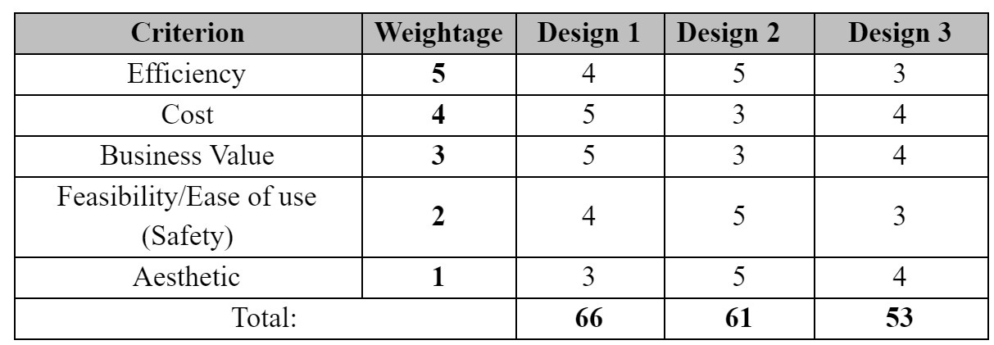

Based on the decision matrix shown, Design 1 had the best score followed by Designs 2 and 3. However, the team collectively believed and decided to choose Design 2 as our final design to be manufactured next semester. This is down to the fact that Design 2 has better cleaning efficiency than Design 1. Due to solar panels being cleaned properly, the team estimated that the need to replace solar panels would decrease as the average lifespan of a panel would increase using better cleaning techniques. This in turn improves the long run maintenance and efficiency of solar panels.
However, the team agreed that there were some recommendations on improvement for Design 2 due to its high cost and maintenance. Firstly, some of the aspects of Design 1 such as materials used and type of frame for the robot will be considered in Design 2. Besides that, the team plans to use cheaper alternative materials with the same standard of quality in order to reduce manufacturing cost. The team also plans to add on a dirt tracking system and a filter to recycle water in Design 2 to further enhance the quality of the design. If applied, all of these changes will be made in the Implement and Operate part of CDIO which will be carried out in the following semester.

REFERENCES
[1] IR. Abdul Aziz, "Solar Panel Maintenance & Cleaning Issue", Mukim Tanjung 12, Sepang, 2019.
[2] "Best Way to Clean Solar Panels - Energy Informative", Energy Informative, 2019. [Online]. Available: https://energyinformative.org/solar-panel-cleaning/. [Accessed: 11- Apr- 2019].
[3] "Solar Panel Cleaning Systems", energy, 2019. [Online]. Available: http://energy.asu.edu.jo/index.php/r-d/solar-panel-cleaning-system. [Accessed: 11- Apr- 2019].
[4] C. Tan, "Energised by the sun - Environment | The Star Online", Thestar.com.my, 2019. [Online]. Available: https://www.thestar.com.my/news/environment/2014/02/24/energised-by-the-sun/. [Accessed: 11- May- 2019].
[5] "TNB connects first phase of Malaysia’s largest solar project to the grid", PV Tech, 2019. [Online]. Available: https://www.pv-tech.org/news/tnb-connects-malaysias-largest-solar-project-to-the-grid. [Accessed: 11- Apr- 2019].
[6] "Worldwide CDIO Initiative", Cdio.org, 2019. [Online]. Available: http://www.cdio.org/. [Accessed: 11- Apr- 2019].
[7] "Green energy options - Nation | The Star Online", Thestar.com.my, 2019. [Online]. Available: https://www.thestar.com.my/news/nation/2019/03/31/green-energy-options/. [Accessed: 13- Apr- 2019].
[8] "TNB secures RM144mil financing for solar project - Business News | The Star Online", Thestar.com.my, 2019. [Online]. Available: https://www.thestar.com.my/business/business-news/2019/01/11/tnb-secures-rm144mil-financing-for-solar-project/. [Accessed: 13- Apr- 2019].
[9] Mr. Idham, "Fortune 11's Solar Farm", Sepang, Selangor, 2019.
[10] Mr. Johari, "Cleaning Methods of Solar Panels", Sepang, Selangor, 2019.
[11] IR. Abdul Aziz, "Solar Panel Maintenance & Cleaning Issue", Mukim Tanjung 12, Sepang, 2019.
[12] "About Kärcher | Kärcher", Kaercher.com, 2019. [Online]. Available: https://www.kaercher.com/my/inside-kaercher/company/about-kaercher.html. [Accessed: 19- Apr- 2019].
[13] S3.kaercher-media.com, 2019. [Online]. Available: https://s3.kaercher-media.com/asset/10023/1444978783/guiding_principles_en.pdf. [Accessed: 19- Apr- 2019].
[14] "Karcher Professional Commercial Solar Panel Cleaners | Kärcher", Kaercher.com, 2019. [Online]. Available: https://www.kaercher.com/us/professional/isolar-clean-solar-modules-effectively-and-increase-electricity-production.html. [Accessed: 26- Apr- 2019].
[15] "Home - Ecoppia - Robotic Solar Cleaning Solution", Ecoppia - Robotic Solar Cleaning Solution, 2019. [Online]. Available: https://www.ecoppia.com/. [Accessed: 10- May- 2019].
[16] M. Meller and E. Meller, "Solar panel cleaning system and method", US8771432B2, 2014.
[17]"The world’s first fully automated UAV for cleaning solar panels – Aerial Power introduces the worlds first cleaning drone.", Aerialpower.com, 2019. [Online]. Available: https://www.aerialpower.com/solarbrush/. [Accessed: 10- May- 2019].
[18] "Solar Panel Cleaning - Automatic Cleaning System: Heliotex", Solarpanelcleaningsystems.com, 2019. [Online]. Available: https://www.solarpanelcleaningsystems.com/. [Accessed: 10- May- 2019].
[19] G. Hunt and M. Workman, "Solar panel cleaning system", US20090288691A1, 2009.
[20] F. Zanatta, "Automatic washing device for continuous surfaces, in particular solar thermal collectors, photovoltaic panels, continuous glazed building walls and similar surfaces", US9192966B2, 2015.
[21] "Washpanel - Sistemi automatici per il lavaggio di impianti solari", Washpanel.com, 2019. [Online]. Available: http://www.washpanel.com/. [Accessed: 10- May- 2019].
[22] "Cleaning the world! - Cleandrone", Cleandrone, 2019. [Online]. Available: http://www.cleandrone.com/. [Accessed: 10- May- 2019].
[23] R. Pardell, "Agcfds: automated glass cleaning flying drone system", US20170210470A1, 2017.
[24] P. Vasiljev, S. Borodinas, R. Bareikis and A. Struckas, "Ultrasonic system for solar panel cleaning", Sensors and Actuators A: Physical, vol. 200, pp. 74-78, 2013. Available: 10.1016/j.sna.2013.01.009.
[25] H. Kawamoto, "Electrostatic cleaning equipment for dust removal from soiled solar panels", Journal of Electrostatics, vol. 98, pp. 11-16, 2019. Available: 10.1016/j.elstat.2019.02.002.
[26] "Say Goodbye To Solar Panel Cleaning | Ultimate Efficiency | Solar Sharc®", Solar Sharc®, 2019. [Online]. Available: https://solarsharc.com/. [Accessed: 10- May- 2019].
[27] "Five common myths about ‘self-cleaning’ coatings | SOLAR SHARC®", Solar Sharc®, 2019. [Online]. Available: https://solarsharc.com/optimising-pv-efficiency/five-common-myths-self-cleaning-coatings/. [Accessed: 10- May- 2019].
[28] A. O'Sullivan and S. Sheffrin, Economics. Boston, Mass.: Pearson/Prentice Hall, 2007.
[29] N. Bendle, P. Farris, P. Pfeifer and D. Reibstein, Marketing metrics, 2010
[30] Mr. Johari, "Cleaning Methods of Solar Panels Used by Fortune 11", Sepang, Selangor, 2019.
[31] "Water Tariff » Syarikat Bekalan Air Selangor Sdn. Bhd. (SMS & Helpline:15300)", Syabas.com.my, 2019. [Online]. Available: https://www.syabas.com.my/consumer/water-bill-water-tariff. [Accessed: 21- Jun- 2019]
[32] "Feed-In Tariff (FiT) Guidelines – SEDA", Seda.gov.my, 2019. [Online]. Available: http://www.seda.gov.my/download/seda-guidelines/fit-guidelines/. [Accessed: 21- Jun- 2019].
[33] M. Phillipy, "Delivering business value: The most important aspect of project management", in PMI® Global Congress 2014, Phoenix, Arizona, 2014.
[34] IR. Abdul Aziz, "Solar Panel Maintenance & Cleaning Issue", Mukim Tanjung 12, Sepang, 2019.
[35] Dr. Nicoletta Ferretti, "White Paper - PV Module Cleaning - Market Overview and Basics", Berlin, 2018.
[36] A. Syafiq, A. Pandey, N. Adzman and N. Rahim, "Advances in approaches and methods for self-cleaning of solar photovoltaic panels", Solar Energy, vol. 162, pp. 597-619, 2018. Available: 10.1016/j.solener.2017.12.023.
[37] "Best Way to Clean Solar Panels - Energy Informative", Energy Informative, 2019. [Online]. Available: https://energyinformative.org/solar-panel-cleaning/. [Accessed: 22- June- 2019].
[38] Engineering Tutorials. (2013). Introduction of Kinematics of Machines - Engineering Tutorials. [online] Available at: http://engineering.myindialist.com/2013/introduction-of-kinematics-of-machines/#.XR3jXJMzbR0 [Accessed 5 Jul. 2019].
[39] Cs.cmu.edu. (2019). Chapter 4. Basic Kinematics of Constrained Rigid Bodies. [online] Available at: https://www.cs.cmu.edu/~rapidproto/mechanisms/chpt4.html [Accessed 5 Jul. 2019].
[40] Australian Taxation Office, "Business viability assessment tool", Australian Government, Australia, 2017.

